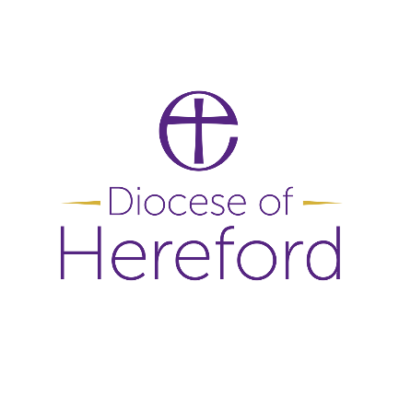
Area
Co-Ordinator
We are looking to employee someone to oversee and co-ordinate administration in the Condover Deanery,
as agreed with local parishes.
Supporting the work of the Rural Church Missioner.
This is a new pilot project and initially funded for 3 years.

The post holder would work from home, but there is a need to regularly meet with the Rural Church Missioner, travel across the Deanery and attend in person meetings.

The role is part time – 17.5 hours, Monday to Friday with some evening and weekend work on occasions.

£12,239 Per Annum

For a conversation, please contact Revd Gareth Ingram
on 07753 336995
Application details: www.hereford.anglican.org/vacancies

Application closure date 9am: 9th November 2026
Interview date: 20th November 2026

We are committed to equal opportunities and diversity and welcome applications from all suitably qualified people. As UKME /GMH individuals are currently under-represented within our Diocese - we would particularly welcome applications from these candidates.
.

