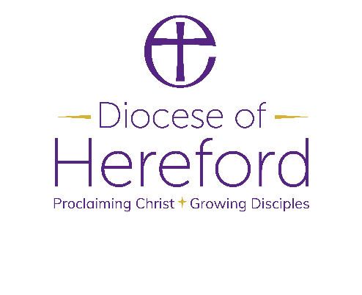
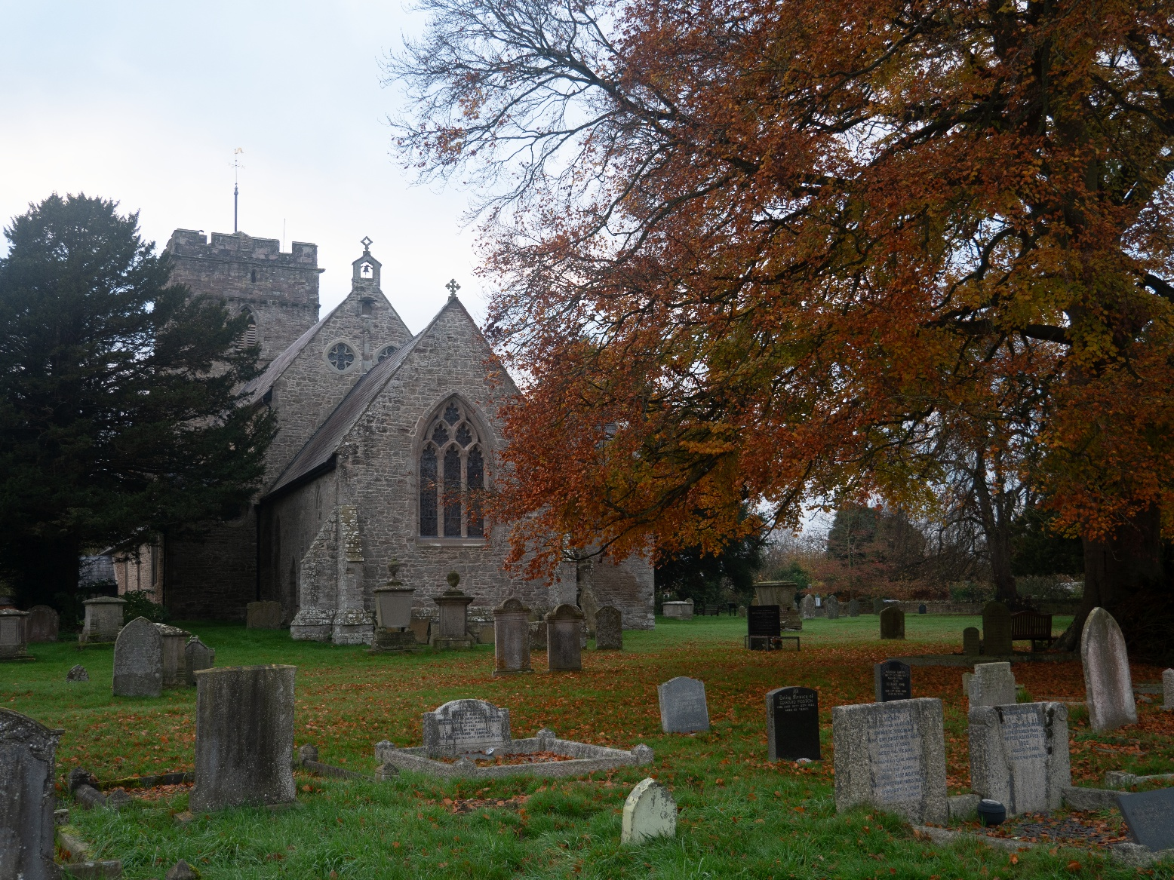
Prayer Diary
September – November 2026

www.hereford.anglican.org

Our 1350th Anniversary

In 2026 we are celebrating the 1350th anniversary of the founding of Hereford Diocese, in 676AD, and the people and places that make up this very special place, with a Year of Celebration.

Listings of Year of Celebration events and a selection of resources are on our website here: https://hereford.anglican.org/our-faith/1350/. In the meantime, here is a list of key dates for your diary:

Spiritual Question Time

This is a series of locally hosted events that will take place across the diocese. They provide an opportunity to ask questions about faith and explore a Christian perspective on contemporary issues. If you would like to host an event in your parish, benefice or deanery, please get in touch with our comms team. Venues and panellists to be confirmed unless stated.

Wednesday 21 October 2026 - Bridgnorth with Rev’d Suzan Williams, venue TBC
Tuesday 10 November 2026 - with Bishop Richard and Chancellor James Pacey, venue TBC

Celebration of Mission & Ministry

Saturday 10 Oct 2026
- 10:30 am - Celebration of Lay Ministry, including Reader admissions at Ludlow St Laurence
- 2:30 pm - Confirmation Service in Ludlow Archdeaconry, at Ludlow St Laurence, followed by a celebration event hosted by Bishop Richard

Celebration Days | Pilgrimage

Sat 19 Sep 2026 – Much Wenlock, honouring St Milburga; worship and communion led by Bishop Richard
Sat 17 Oct 2026 – Golden Valley / Madley, honouring St Dyfrig; worship and communion led by Bishop Richard

The Deaneries
Hereford Archdeaconry | Ludlow Archdeaconry
- A. Abbeydore | - H. Clun
- B. Bromyard | - I. Condover
- C. Hereford City | - J. Ludlow
- D. Kington and Weobley | - K. Pontesbury
- E. Ledbury | - L. Severn Borders
- F. Leominster
- G. Ross and Archenfield
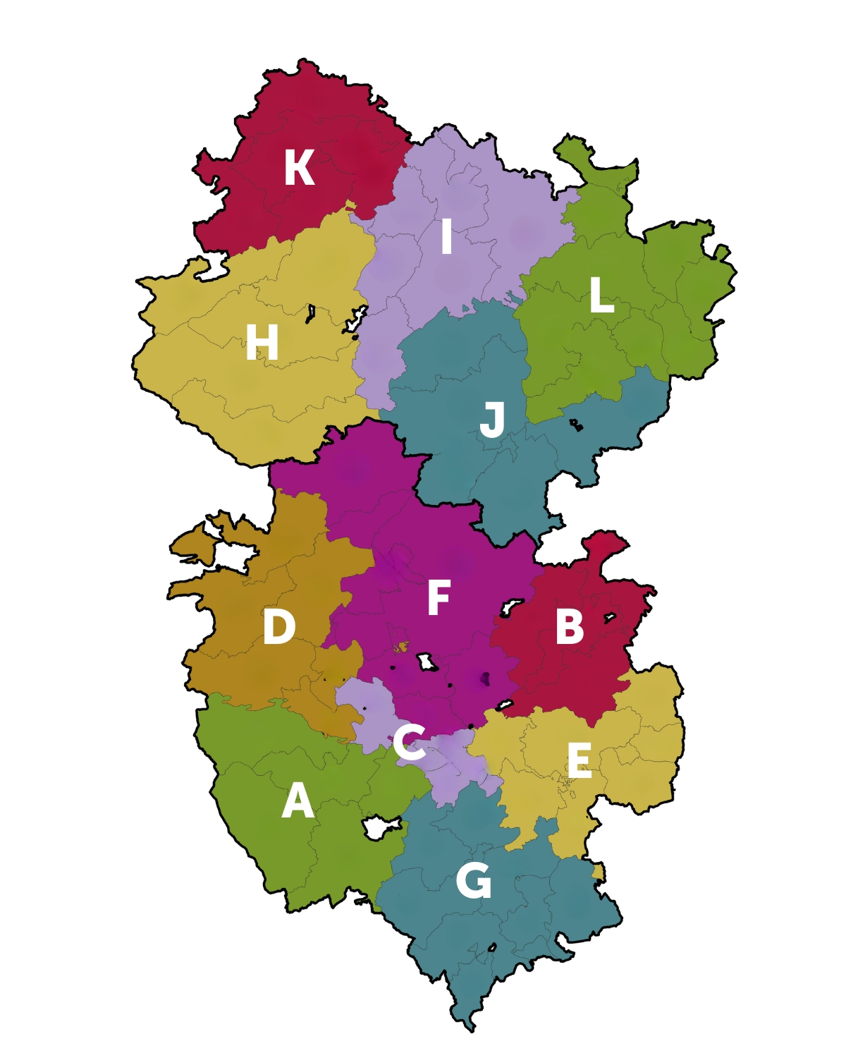

The Prayer Diary – September to November 2026
The main part of this Prayer Diary covers the third quarter of the Church Year, week by week, under the following headings:

- Anglican - Taken from the Anglican Cycle of Prayer and updated as fully and accurately as possible, so that we can pray with confidence with and for the Anglican Communion worldwide.

- Hereford – Each Benefice is prayed for twice a year, our diocesan leaders and all church schools and headteachers, and youth hubs once each year, interspersed with the wider needs of the diocese.

- Porvoo - This weekly bidding pairs the Lutheran churches of the Nordic and Baltic areas and the Anglican churches of the British Isles and of Spain and Portugal, which have signed the Porvoo Declaration recognising each other’s ministries. Also included is the Latvian Church, which has not yet taken a decision on signing the Declaration, and the Church of Denmark, which has not signed but wishes to develop links with the churches which have signed.

- The Wider View - Biddings and promptings for prayer relating to the wider world, the economy and global politics.

- Today – Details on what is happening in the life of the diocese to prompt your own intercessions, such as churchwarden visitations, General Synod meetings and ordinations.

- Prayer – The Anglican Collect for the Sunday prior.

If you would like to submit items for inclusion, ideas, or comments, please email the Bishop’s Chaplain at chaplain@hereford.anglican.org.

You can also view the Prayer Diary on our website under the section Our Faith > Spirituality and Discipleship > Prayer: https://www.hereford.anglican.org/prayer

Week commencing Sunday 6th September
Sunday 6th September |  | Trinity 14 / Proper 18
Anglican | The Episcopal / Anglican Province of Alexandria : Primate, The Most Reverend Dr Samy Shehata
Hereford | The Cathedral, & Dean Sarah Brown
Porvoo | Church of England: Diocese of Salisbury, Bishop Stephen Lake, Bishop Andrew Rumsey, Bishop Karen Gorham  Church in Wales: Diocese of St Asaph, Bishop Gregory Cameron
The Wider View | For all who are struggling with despair, remembering World Suicide Prevention Day (10 September). Bring healing, comfort and renewed hope to all who are in need. We thank you for the gift of learning as we mark International Literacy Day (8 September), and pray that education may open doors of opportunity, dignity and freedom for people of every nation. We also pray for the young people taking part in the FIFA U-20 Women's World Cup in Poland (31 August–13 September), that they may compete with joy, fairness and friendship, building understanding across cultures.
Collect | Lord God, the source of truth and love,  keep us faithful to the apostles’ teaching and fellowship,  united in prayer and the breaking of bread,  and one in joy and simplicity of heart,  in Jesus Christ our Lord.  Amen.
Today | Swearing in of the New Chancellor, Annabel Graham Paul  City Praise  Beginning of 24/7 Prayer week

Monday
Anglican | The Diocese of Bermuda – (Extra Provincial): Right Revd Nicholas Dill
Hereford | Hereford South Wye (Hereford St Martin and Bullinghope): in vacancy
Today | Licensing of Vicki Burrows to Cusop with Blakemere, Bredwardine with Brobury, Clifford, Dorstone, Hardwicke, Moccas and Preston-on-Wye (known as the 'Border Link Parishes')

Tuesday
Anglican | The Diocese of Bethlehem – The Episcopal Church: The Rt Revd Kevin Nichols
Hereford | Hereford St Peter with St Owen and St James: Andy Morgan, Training Curate Alex Herbert Mynors and Assistant Curate Luke Aylen
Today | The Bishop’s Staff Meeting

Wednesday
Anglican | The Diocese of Bhopal – The Church of North India (United): The Rt Revd Neena Charan
Hereford | For all who care for others, at home or in their work, especially those carrying responsibilities which are unseen or demanding.

Thursday
Anglican | The Diocese of Bida – The Church of Nigeria (Anglican Communion): The Rt Revd Jonah G. Kolo
Hereford | Holmer with Huntington: Wayne Davies, and Reader Dave Cappleman

Friday
Anglican | The Diocese of Biharamulo – The Anglican Church of Tanzania : The Right Revd Vithalis Yusuph Sunzu
Hereford | Magnis Group Benefice (Bishopstone, Bridge Sollars, Brinsop with Wormsley, Credenhill, Kenchester, Mansel Lacy with Yazor): Rana Davies-James
Saturday
Anglican | The Diocese of Birmingham – The Church of England : The Right Revd Michael Volland
Hereford | The West Hereford Team Ministry (All Saints Hereford, Breinton, Holy Trinity Hereford, St Nicholas Hereford): Jonathan Widdess, Training Curate Christine Cattanach, and Reader Mike Weaver

Week commencing Sunday 13th September
Sunday 13th September |  | Harvest / Trinity 15 / Proper 19
Anglican | The Anglican Church in Aotearoa, New Zealand and Polynesia : Primates The Most Revd Sione Uluilakepa; The Most Revd Justin Duckworth; The Most Revd Don Tamihere
Hereford | The Hereford City Deanery : Rural Dean, Andy Dodwell
Porvoo | Evangelical Lutheran Church in Denmark: Diocese of Ribe, Bishop Elof Westergaard  Church of England: Diocese of Bath and Wells, Bishop Michael Beasley, Bishop Ruth Worsley (interim bishop in diocese of Liverpool)
The Wider View | For wisdom to those gathering to promote nuclear safety and disarmament (Int. Atomic Energy Agency General Conference and Third Review Conference of the Convention on Cluster Munitions, 14–18 September). Bless all who work to end hunger and support rural communities (Int. Fund for Agr. Development Executive Board, 14–18 September). Inspire integrity and compassion in the world of creativity and commerce during London Fashion Week, 17–21 September,
Collect | God, who in generous mercy sent the Holy Spirit  upon your Church in the burning fire of your love:  grant that your people may be fervent  in the fellowship of the gospel  that, always abiding in you,  they may be found steadfast in faith and active in service;  through Jesus Christ your Son our Lord,  who is alive and reigns with you,  in the unity of the Holy Spirit,  one God, now and for ever.  Amen.

Monday | Holy Cross Day
Anglican | The Diocese of Blackburn – The Church of England : The Right Revd Philip North
Hereford | For courage to live as followers of Jesus, inspired by the cross of Christ.
Today | Bishop Richard begins his Duty Week in the House of Lords

Tuesday
Anglican | The Diocese of Bo – The Church of the Province of West Africa : The Rt Revd Soloman Scott-Manga
Hereford | Tupsley with Hampton Bishop: Andy Dodwell, and Reader Deborah Hartland

Wednesday
Anglican | The Diocese of Boga – Province de L’Eglise Anglicane Du Congo : The Rt Revd William Bahemuka Mugenyi
Hereford | For the Cathedral's ministry of worship, welcome and learning.

Thursday
Anglican | The Diocese of Bolivia – The Anglican Church of South America : In Vacancy
Today | Pembridge with Moorcourt, Shobdon, Staunton-on-Arrow, Byton and Lyonshall (the Arrowvale Group): Anna Branston

Friday
Anglican | The Diocese of Bondo – The Anglican Church of Kenya : The Right Revd Professor David Kodia
Hereford | Letton with Staunton-on-Wye, Byford, Mansel Gamage and Monnington-on-Wye: in vacancy
Saturday
Anglican | The Diocese of Bor – Province of the Episcopal Church of South Sudan : The Most Revd Moses Anur Ayom
Hereford | Kington with Huntington, Old Radnor, Kinnerton and Titley: Sally Welch, Training Curate Phillippa Wright, and Assistant Minister Paul Buckingham
Today | Year of Celebration St Milburga pilgrimage, Much Wenlock

Week commencing Sunday 20th September
Sunday 20th September |  | Harvest / Trinity 15 / Proper 20
Anglican | The Anglican Church of Australia: Primates, The Right Revd Dr Mark Short, The Most Revd Jeremy Greaves; The Most Revd Kay Goldsworthy AO; The Most Revd Kanishka Raffel
Hereford | Kington and Weobley Deanery : Rural Dean Steve Hollinghurst
Porvoo | Church of England: Diocese of Sheffield, Bishop Pete Wilcox, Bishop Leah Vasey-Saunders  Church of Greenland: (Diocese of Greenland within the Evangelical Lutheran Church in Denmark) Bishop Paneeraq Siegstad Munk
The Wider View | For the world as we mark the International Day of Peace (20 September), that hearts would turn from conflict to reconciliation and God will guide all who seek justice and lasting peace. For all whose lives and work are bound to the sea, remembering World Maritime Day (24 September). For protection of those who sail the oceans, for blessing on those who keep both trade and aid moving safely.
Collect | Lord of creation,  whose glory is around and within us:  open our eyes to your wonders,  that we may serve you with reverence  and know your peace at our lives’ end,  through Jesus Christ our Lord.  Amen.

Monday | Matthew, Apostle and Evangelist
Anglican | The Diocese of Botswana – The Church of the Province of Central Africa : The Most Revd Albert Chama
Hereford | For bankers, accountants, bookkeepers, customs officers and all who work in the financial sector – for their wisdom, integrity and a call into transformation through God’s grace.

Tuesday
Anglican | The Diocese of Brandon – The Anglican Church of Canada : The Right Revd Rachael Parker
Hereford | Presteigne with Discoed, Kinsham, Lingen and Knill: Steve Hollinghurst, and Assistant Minister Debbie Venables
Today | Bishop begins his 12-day Visit to the Diocese of Masasi, Tanzania

Wednesday | Ember Day
Anglican | The Diocese of Brechin – The Scottish Episcopal Church : The Rt Revd Andrew Swift
Hereford | The social services. All who work in the criminal justice system, victims and perpetrators of crime. The work of aid agencies throughout the world and those living in poverty or under oppression.

Thursday
Anglican | The Diocese of Brisbane – The Anglican Church of Australia : The Most Revd Jeremy Greaves
Hereford | Weobley with Sarnesfield and Norton Canon: in vacancy

Friday
Anglican | The Diocese of Bristol – The Church of England : In Vacancy
Hereford | Colwall with Upper Colwall and Coddington: Melanie Horton
Saturday
Anglican | The Diocese of British Columbia – The Anglican Church of Canada : The Right Revd Anna Greenwood-Lee
Hereford | Eardisley with Bollinghamand Willersley, Brilley, Michaelchurch, Whitney, Winforton, Almeley and Kinnersley: Marcus Small, and Licensed Lay Funeral Minister Gill Layton

Week commencing Sunday 27th September
Sunday 27th September |  | Harvest / Trinity 16 / Proper 21
Anglican | The Church of Bangladesh : Primate, The Most Revd Samuel Sunil Mankhin
Hereford | The Ledbury Deanery, Rural Dean Vacant & the Diocese of Masasi as they celebrate their Centenary
Porvoo | Church in Wales: Diocese of Swansea and Brecon, Bishop John Lomas  Church of England: Diocese of Leicester, Bishop Martyn Snow, Bishop Saju Mathalaly
The Wider View | For nations most affected by climate change, especially low-lying island states and coastal communities, remembering the United Nations High-Level Meeting on Sea-Level Rise (late September); that leaders would respond with urgency, justice and compassion to those whose homes and livelihoods are increasingly at risk.  For ministers, judges, law-enforcement agencies and all working to uphold justice during the 15th United Nations Congress on Crime Prevention and Criminal Justice (26 September–1 October); that organised crime, human trafficking and exploitation would be challenged, victims protected, and the rule of law strengthened throughout the world.  For the work of the United Nations General Assembly Committees (beginning 1 October), as delegates begin detailed negotiations on disarmament, economic development and human rights; that their deliberations would be marked by wisdom, integrity and a shared commitment to the flourishing of all people.
Collect | Gracious God,  you call us to fullness of life:  deliver us from unbelief  and banish our anxieties  with the liberating love of Jesus Christ our Lord.  Amen.

Monday
Anglican | The Diocese of Central Buganda – The Church of the Province of Uganda : The Rt Revd Michael Lubowa
Hereford | Fownhope with Mordiford, Brockhampton and Woolhope: Chris Moore

Tuesday | Micheal and All Angels
Anglican | The Diocese of West Buganda – The Church of the Province of Uganda : The Rt Revd Henry Katumba-Tamale
Hereford | For police officers, soldiers, firefighters, paramedics, mariners, and all who protect others.

Wednesday
Anglican | The Diocese of Buhiga – The Anglican Church of Burundi : The Right Revd Evariste Nijimbere
Hereford | For pupils, students, teachers and school staff beginning a new academic year, especially those facing change or uncertainty.

Thursday
Anglican | The Diocese of Bujumbura – The Anglican Church of Burundi : The Right Revd Eraste Bigirimana
Hereford | Ledbury with Eastnor: in vacancy, Associate Minister William Simmonds, Pioneer Associate Minister Tony Hodder, and Reader Mary Keyes

Friday
Anglican | The Diocese of Bukavu – Province de L’Eglise Anglicane Du Congo : The Rt Revd Sylvestre Bahati Balisusane
Hereford | The Cider Churches (Aylton, Little Marcle, Much Marcle, Pixley, Putley, Wellington Heath, Yatton): Val Tait, and Associate Minister William Simmonds
Saturday
Anglican | The Diocese of Bukedi – The Church of the Province of Uganda
Hereford | Cradley with Mathon and Storridge: Rosie Roberts

Week commencing 4th October
Sunday 4th October |  | Harvest / Trinity 18 / Proper 22
Anglican | Igreja Episcopal Anglicana do Brasil : Primate The Most Revd Marinez Rosa Dos Santos Bassotto
Hereford | The Bromyard Deanery: Rural Dean Dawn Hyett
Porvoo | Church of England: Diocese of Liverpool, vacancy – bishop of Liverpool, vacancy – bishop of Warrington, Bishop Ruth Worsley (interim bishop)  Church in Wales: Diocese of Monmouth, Archbishop Cherry Vann (Archbishop of Wales)  Evangelical Lutheran Church in Denmark: Diocese of Haderslev, Bishop Marianne Christiansen
The Wider View | For governments, aviation authorities and technical experts meeting through the International Civil Aviation Organization (ICAO) Committee Phase and Air Navigation Commission (continuing until 9 October); for wisdom in improving the safety, security and sustainability of international air travel.  For all preparing for the Annual Meetings of the International Monetary Fund and the World Bank (13–18 October); that those entrusted with shaping the global economy would seek policies that foster justice, reduce poverty and support nations facing economic hardship.  For all living with mental ill-health, and for their families, carers and healthcare professionals, as we observe World Mental Health Day (10 October); that they would know compassion, receive the care they need, and find hope and healing.
Collect | God, our judge and saviour,  teach us to be open to your truth  and to trust in your love,  that we may live each day  with confidence in the salvation which is given  through Jesus Christ our Lord.  Amen.

Monday
Anglican | The Diocese of Bukuru – The Church of Nigeria (Anglican Communion) : The Rt Revd Jwan B. N. Zhumbes
Hereford | Lugwardine with Bartestree, Weston Beggard, Dormington, Westhide and Withington - (The Bartestree Cross Group): Tiffany Jackson, and Training Curate Suanna Rosier
Today | Licensing of Richard Lonsdale to the Chirbury Hills Benefice

Tuesday
Anglican | The Diocese of Bunbury – The Anglican Church of Australia :
Hereford | The Hop Churches (Ashperton, Bosbury, Canon Frome, Munsley, Stoke Edith, Stretton Grandison with Asperton, Tarrington, Yarkhill): Mandy Williams, Curate Linde Melhuish, and Reader Michael Llywelyn-Jones

Wednesday
Anglican | The Diocese of Bungoma – The Anglican Church of Kenya : The Rt Revd Dr Ian Coutts
Hereford | For farming families preparing for the autumn season, and for safety during harvests.

Thursday
Anglican | The Diocese of Bunyoro-Kitara – The Church of the Province of Uganda : The Rt Revd Samuel Kahuma
Hereford | Burghill Group of Parishes (Burghill, Moreton-on-Lugg, Pipe-cum-Lyde, Stretton Sugwas): Phill Brown

Friday
Anglican | The Diocese of Busan – The Anglican Church of Korea : The Most Revd Onesimus Dongsin Park
Hereford | Kingsland with Eardisland, Aymestrey and Leinthall Earles: Maggie Tate-Druiff, and Reader Wendy Maddocks
Saturday
Anglican | The Diocese of Busoga – The Church of the Province of Uganda : The Rt Revd Grace Lubaale
Hereford | Canon Pyon with King’s Pyon, Birley and Wellington: Anne Price
Today | The Celebration of Lay Ministries & The Diocesan Festival Confirmation Service, both in Ludlow. Youth Hubs Celebration.

Week commencing Sunday 11th October
Sunday 11th October |  | Harvest / Trinity 19 / Proper 23
Anglican | The Anglican Church of Burundi : The Most Revd Sixbert Macumi
Hereford | The Leominster Deanery : Rural Dean Mark Long, Assistant Rural Dean Paul Roberts
Porvoo | Church of England: Diocese of Truro, Bishop David Williams, Bishop Hugh Nelson  Church of Norway: Diocese of Tönsberg, Bishop Jan Otto Myrseth  Church of Sweden: Diocese of Strängnäs, Bishop Johan Dalman
The Wider View | For farmers, agricultural workers, food producers and all who face hunger, as we mark World Food Day (16 October); that the world's resources would be shared more justly, food systems strengthened, and all people enabled to live with dignity and hope.  For those living in poverty, and for all working to address inequality and injustice, remembering the International Day for the Eradication of Poverty (17 October); that opportunities would grow, burdens be lifted, and communities flourish through fairness, generosity and peace.  For the Archbishop of Canterbury, her ministry, leadership, wisdom as she visits Hereford during its 1350th year celebrations.
Collect | Faithful Lord,  whose steadfast love never ceases  and whose mercies never come to an end:  grant us the grace to trust you  and to receive the gifts of your love,  new every morning,  in Jesus Christ our Lord.  Amen.

Monday
Anglican | The Diocese of Central Busoga – The Church of the Province of Uganda : The Rt Revd Grace Lubaale
Hereford | Leominster, Team Ministry (Bockleton, Brimfield, Croft with Yarpole and Lucton, Dilwyn and Stretford, Docklow, Eye, Eyton, Hatfield, Hope-under-Dinmore, Humber, Ivington, Kimbolton with Hamnish, Leominster, Leysters, Middleton-on-the-Hill, Monkland, Orleton, Pudleston-cum-Whyle, Stoke Prior and Ford): Guy Cole, Matthew Burns, Mark Long, Assistant Curate Fiona Honeysett, Training Curate William Talbot-Ponsonby

Tuesday
Anglican | The Diocese of Butare – Eglise Anglicane du Rwanda : The Rt Revd Christophe Nshimiyimana
Hereford | Wigmore Abbey (Leintwardine, Adforton, Pipe Aston, Brampton Bryan, Downton, Elton, Leinthall Starkes, Wigmore): Adrian Thompson, Distinctive Deacons Lucy Thompson and Lizzy Womack

Wednesday
Anglican | The Diocese of Butere – The Anglican Church of Kenya : The Rt Revd Rose Okeno
Hereford | For those whose work depends on tourism and hospitality as the summer season draws to a close.

Thursday
Anglican | The Diocese of Buye – The Anglican Church of Burundi : The Most Revd Sixbert Macumi
Hereford | The Maund Group: in vacancy, Licensed Lay Funeral Minister Keith Lawton

Friday
Anglican | The Diocese of Byumba – Eglise Anglicane du Rwanda : The Rt Revd Emmanuel Ngendahayo
Hereford | The Bromfield Benefice (Bitterley with Middleton, Bromfield, Clee St Margaret and Cold Weston, Onibury, Stanton Lacy, Stoke St Milborough with The Heath and Hopton Cangeford): Justin Parker
Saturday
Anglican | The Diocese of Calabar – The Church of Nigeria (Anglican Communion) : The Rt Revd Nneoyi Egbe
Hereford | Cleobury Mortimer with Hopton Wafers, Neen Sollars and Milson, Neen Savage with Kinlet and Doddington: Ashley Buck, Assistant Curate Sarah Lupton, Associate Martin Quayle, Reader Charlie Houston
Today | Year of Celebration Day Pilgrimage, St Dyfrig, Madley

Week commencing Sunday 18th October
Sunday 18th October |  | Luke the Evangelist
Anglican | The Anglican Church of Canada : Primate The Most Revd Shane Parker
Hereford | The Ludlow Deanery : Rural Dean Ashley Buck
Porvoo | Church of Sweden: Diocese of Växjö, Bishop Fredrik Modéus  Church of England: Diocese of Oxford, Bishop Steven Croft, Bishop Dave Bull, Bishop Gavin Collins, Bishop Mary Gregory
The Wider View | For governments preparing to gather for the UN Biodiversity Conference (COP17), scheduled for late October, and for all working to protect the natural world; that nations would act with courage to safeguard biodiversity, address climate change and care faithfully for creation.  For Members of Parliament, local authorities and all entrusted with public service in the United Kingdom, as Parliament continues its autumn business; that legislation and public policy would promote justice, protect the vulnerable and strengthen communities.  For the National Health Service, as winter approaches; for doctors, nurses, paramedics, carers and all who support patients, that they would be strengthened in their work, provided with the resources they need, and upheld with wisdom, compassion and resilience in the face of increasing demand.
Collect | Almighty God,  you called Luke the physician,  whose praise is in the gospel,  to be an evangelist and physician of the soul:  by the grace of the Spirit  and through the wholesome medicine of the gospel,  give your Church the same love and power to heal;  through Jesus Christ your Son our Lord,  who is alive and reigns with you,  in the unity of the Holy Spirit,  one God, now and for ever.  Amen.

Monday | Luke the Evangelist
Anglican | The Diocese of Calcutta – The Church of North India (United) : The Most Revd Dr Paritosh Canning
Hereford | The Ludlow Benefice (St Giles, St John, St Laurence): in vacancy, Reader Caroline Culley

Tuesday
Anglican | The Diocese of Caledonia – The Anglican Church of Canada : The Right Revd David Lehmann
Hereford | The Ashfords Benefice (Ashford Bowdler, Ashford Carbonell, Caynham, Knowbury, Richard’s Castle): in vacancy

Wednesday
Anglican | The Diocese of Calgary – The Anglican Church of Canada : The Most Revd Gregory Kerr-Wilson
Hereford | The cast and crew of the Hereford Mysteries, as they seek to bring stories alive, and for all who watch.
Today | Spiritual Question Time – Bridgnorth and Morville Benefice

Thursday
Anglican | The Diocese of California – The Episcopal Church : The Rt Revd Austin Rios
Hereford | The Corvedale Benefice (Abdon, Culmington, Diddlebury, Holdgate, Munslow, Tugford): John Beesley

Friday
Anglican | The Diocese of Northern California – The Episcopal Church : The Rt Revd Megan Traquair
Hereford | The Tenbury Team Ministry (Burford 3rd Portion, Clee Hill, Coreley, Greete, Hope Bagot, Little Hereford, Nash and Boraston, Tenbury Wells St Mary’s, Tenbury Wells St Michael’s, Whitton): Lawrence Gittins, Mark Inglis, Associate Minister Sue Foster, Readers Kevin Bryant and Stephen Barlow
Today | The Hereford Mysteries at Hereford Cathedral
Saturday
Anglican | The Diocese of Cameroon – The Church of the Province of West Africa : The Rt Revd Dibo Thomas-Babyngton Elango
Hereford | Chirbury, Marton, Middleton and Trelystan with Leighton: Richard Lonsdale
Today | The Hereford Mysteries at Hereford Cathedral

Week commencing Sunday 25th October
Sunday 25th October |  | Proper 25 | Last after Trinity
Anglican | The Church of the Province of Central Africa : Primate, The Most Revd Albert Chama
Hereford | The Pontesbury Deanery : Rural Dean Greg Smith
Porvoo | Church of England: Diocese of Carlisle, Bishop Robert Saner-Haigh  Church of Norway: Diocese of Stavanger, Bishop Anne Lise Ådnøy
The Wider View | For the people of Israel, as they vote in the Knesset election (27 October) amid deep division and the consequences of conflict; for the safety of voters, wisdom in the choices made, and leadership committed to justice, security, reconciliation and peace for Israelis and Palestinians alike.  For foreign ministers gathering for the G20 Foreign Ministers’ Meeting in Atlanta (30–31 October); that rivalry between powerful nations would not prevent cooperation, and that their discussions would advance peace, international stability and practical responses to the needs of poorer and conflict-affected countries.  For the Armed Forces, particularly those serving overseas or separated from their families; for protection in danger, wisdom and restraint in the use of force, care for those wounded or traumatised by service, and lasting support for veterans, reservists and military families.
Collect | Merciful God,  teach us to be faithful in change and uncertainty,  that trusting in your word  and obeying your will  we may enter the unfailing joy of Jesus Christ our Lord.  Amen.
Today | Order of St Ethelbert Awards Evensong  City Praise at Hereford Cathedral

Monday
Anglican | The Diocese of El Camino Real – The Episcopal Church : The Rt Revd Lucinda Ashby
Hereford | Minsterley, Habberley and Hope with Shelve: Greg Smith

Tuesday
Anglican | The Diocese of Canberra and Goulburn – The Anglican Church of Australia : The Right Revd Dr Mark Short
Hereford | Ford, Great Wollaston and Alberbury with Cardeston: Stephen Griffiths
Wednesday | Simon and Jude, Apostles
Anglican | The Diocese of Canterbury – The Church of England : The Most Revd and Right Hon Dame Sarah Mullally
Hereford | For all those who champion what to the world would seem like a lost cause, and who provide a beacon of hope for those who despair.

Thursday
Anglican | The Diocese of Cape Coast – The Church of the Province of West Africa : The Rt Revd Victor Atta-Baffoe
Hereford | Great Handwood, Longden and Annscroft with Pulverbatch: in vacancy, Curate Freddie Strong, Assistant Curate-in-Training Tracy Jones

Friday
Anglican | The Diocese of Cape Town – The Anglican Church of Southern Africa : The Most Revd Dr Thabo Makgoba
Hereford | Pontesbury: Greg Smith, Assistant Curate-in-Training Ian Williams
Saturday
Anglican | The Diocese of North Eastern Caribbean and Aruba – The Church in the Province of the West Indies : In Vacancy
Hereford | Westbury, Worthen and Yockleton: David Moss

Week commencing Sunday 1st November
Sunday 1st November |  | All Saints
Anglican | Iglesia Anglicana de la Region Central de America :  Primate of IARCA & Bishop of El Salvador: The Most Revd Juan David Alvarado Melgar. Primate-elect of IARCA & Bishop of Guatemala: The Right Revd Ramón Ovalle
Hereford | The Ross and Archenfield Deanery : Rural Dean David Howell
Porvoo | Church of England: Diocese of Winchester, Bishop Philip Mounstephen, Bishop Rhiannon King, Bishop Kelly Betteridge,  Church of Norway: Diocese of Agder and Telemark, Bishop Stein Reinertsen
The Wider View | For journalists, broadcasters and all who seek to report the truth, as we mark the International Day to End Impunity for Crimes against Journalists (2 November); that freedom of the press would be upheld, those who risk their lives to uncover the truth would be protected, and justice would prevail where violence and intimidation seek to silence them.  For those who find the shortening days and longer nights difficult; for those who live alone, who grieve, who struggle with loneliness or poor mental health, and for all who will find this season especially challenging; that they would know the light of Christ through the love, friendship and practical care of those around them.
Collect | God of holiness,  your glory is proclaimed in every age:  as we rejoice in the faith of your saints,  inspire us to follow their example  with boldness and joy;  through Jesus Christ our Lord.  Amen.

Monday
Anglican | The Diocese of Carlisle – The Church of England : The Right Revd Rob Saner-Haigh
Hereford | Ariconium: (Aston Ingham, Hope Mansel, Linton, The Lea, Upton Bishop, Weston-under-Penyard): David Howell, and Training Curate Ewan Gillings

Tuesday
Anglican | The Diocese of East Carolina – The Episcopal Church : The Rt Revd Sarah Fisher
Hereford | Archenfield (Garway, Hentland with Hoarwithy, Orcop, Pencoyd and Tretire with Michaelchurch, St Weonards): Angie Kateley
Today | Bishop’s Staff Meeting, Licensing of Sarah Hillman to Ledbury

Wednesday
Anglican | The Diocese of North Carolina – The Episcopal Church : The Rt Revd Samuel Rodman
Hereford | For all chaplains serving prisons, schools and the armed forces.

Thursday
Anglican | The Diocese of South Carolina – The Episcopal Church : The Rt Revd Ruth Woodliff-Stanley
Hereford | Ross with Walford and Brampton Abbotts: Kelvin Price, and Associate Minister Caroline Pascoe

Friday
Anglican | The Diocese of Upper South Carolina – The Episcopal Church : The Rt Revd Daniel Richards
Hereford | South Wye Rural (Little Dewchurch, Ballingham, Dinedor and Holme Lacy): Mark Johnson
Saturday
Anglican | The Diocese of Western North Carolina – The Episcopal Church : The Rt Revd José Antonio McLoughlin
Hereford | The Wye Brooks Benefice (Goodrich and Welsh Bicknor, Llangarron, Llangrove, Marstow, Welsh Newton with Llanrothal): in vacancy, Associates Simon Tarlton and Mark Melluish
Today | Quiet morning for NSM’s, Lay worship leaders and Readers

Week commencing Sunday 8th November
Sunday 8th November |  | Remembrance
Anglican | Province de L’Eglise Anglicane Du Congo : Archbishop The Most Revd Georges Titre Ande
Hereford | The Condover Deanery : Rural Dean Chris Hargraves
Porvoo | Church of England: Diocese of Norwich, Bishop Graham Usher, Bishop Ian Bishop, Bishop Jane Steen  Church of Sweden: Diocese of Luleå, Bishop Åsa Nyström
The Wider View | For all preparing to mark Remembrance Sunday (8 November); for veterans, serving members of the Armed Forces, their families and all who bear the physical or emotional scars of conflict, that our remembrance of the past would strengthen our resolve to work for peace and reconciliation.  For scientists, engineers and policymakers gathering for UNESCO's World Science Forum (10–13 November); that scientific discovery would be used wisely, ethically and for the benefit of all people, especially in addressing global challenges such as health, food security and environmental sustainability.  For businesses, investors and governments participating in Global Entrepreneurship Week (beginning 9 November); that innovation would serve the common good, create dignified employment and encourage economic opportunity, particularly in poorer communities.  For all who are homeless, isolated or anxious as winter draws nearer; for charities, churches, food banks and community organisations, that they would be strengthened in their service, and that those in greatest need would find warmth, companionship and hope.
Collect | God, our refuge and strength,  bring near the day when wars shall cease  and poverty and pain shall end,  that earth may know the peace of heaven  through Jesus Christ our Lord.  Amen.

Monday
Anglican | The Diocese of Cashel, Ferns and Ossory – The Church of Ireland
Hereford | StowCaple (Bridstow, Foy, How Caple, King’s Caple, Peterstow, Sellack, Sollershope): Laura Hewitt

Tuesday
Anglican | The Diocese of Chandigarh – The Church of North India (United)
Hereford | Wormelow Hundred (Dewsall with Callow, Little Birch, Llandinabo, Llanwarne, Much Birch, Much Dewchurch): Mark Johnson
Today | Clergy Quiet Morning & Spiritual Question Time in Church Stretton

Wednesday
Anglican | The Diocese of Chelmsford – The Church of England : The Rt Revd Dr Guli Francis-Dehqani
Hereford | For choirs, musicians and all enriching worship through music.

Thursday
Anglican | The Diocese of Chester – The Church of England : The Rt Revd Mark Tanner
Hereford | Wye Reaches Group (Bishopswood, Dixton, Ganarew, Whitchurch): Tim Starling

Friday
Anglican | The Diocese of Chhattisgarh – The Church of North India (United) : The Rt Revd Sushma Kumar
Hereford | Alvely and Quatt: Jon Aldwinckle, Licensed Lay Worker Wendy Aldwinckle
Saturday | St Dubricious

Anglican | The Diocese of Chicago – The Episcopal Church : The Rt Revd Paula Eldreda Clark
Hereford | For The Wye River, for those who are seeking to protect it and for those whose livelihoods depend upon its flourishing.

Week commencing Sunday 15th November
Sunday 15th November |  | 2nd before Advent
Anglican | Iglesia Anglicana de Chile : The Most Revd Enrique Lago Zugadi
Hereford | The Severn Borders Deanery : Rural Dean Jeannetta Stokes, Assistant Rural Dean Dawn Taffinder
Porvoo | Estonian Evangelical Lutheran Church: Archbishop Urmas Viilma, Bishop Ove Sander (Northern Estonia), Bishop Marko Tiitus (Southern Estonia), Bishop Anti Toplaan (Western Estonia and the Islands)  Church of England: Diocese of Rochester, Bishop Jonathan Gibbs, Bishop Simon Burton-Jones
The Wider View | For world leaders gathering at the G20 Leaders' Summit (15–16 November); that amid economic uncertainty and international tension they would seek cooperation over division, work for the common good, and protect the poorest and most vulnerable nations.  For bishops, clergy and lay representatives meeting for the General Synod of the Church of England (16–18 November); that they would be guided by the Holy Spirit in their deliberations, strengthen the Church's witness to the Gospel, and seek the unity and flourishing of the whole Church.  For the police, neighbourhood policing teams, Police Community Support Officers, and all who serve in West Mercia Police; for wisdom, courage and integrity in their work, for protection as they serve the public, and for strong relationships of trust with the communities of Herefordshire and beyond.
Collect | Heavenly Lord,  you long for the world’s salvation:  stir us from apathy,  restrain us from excess  and revive in us new hope  that all creation will one day be healed  in Jesus Christ our Lord.  Amen.

Monday
Anglican | The Diocese of Chichester – The Church of England : The Rt Revd Martin Warner
Hereford | Broseley with Benthall, Jackfield, Linley with Willey and Barrow: Lynda Lilley, and Reader Rebecca Wood

Tuesday
Anglican | The Diocese of Chotanagpur – The Church of North India (United) : The Rt Revd B. B. Baskey
Hereford | Claverley with Tuckhill: in vacancy

Wednesday
Anglican | The Diocese of Christ the King – Igreja Anglicana de Mocambique e Angola
Hereford | For a growth of community spirit, for all those neighbours who watch over one another in our towns and villages.

Thursday
Anglican | The Diocese of Christ the King – The Anglican Church of Southern Africa
Hereford | Ditton Priors with Wheathill and Loughton and Neenton, Burwarton, Cleobury North, Aston Botterell, Chetton: Joe Simons, and Reader Dot Cartwright

Friday
Anglican | The Diocese of Christchurch – The Anglican Church in Aotearoa, New Zealand and Polynesia
Hereford | Coalbrookdale, Ironbridge with Little Wenlock: Ernest Okeke
Saturday
Anglican | The Diocese of Chubu – The Nippon Sei Ko Kai
Hereford | Highley with Billingsley, Glazeley and Deuxhill and Chelmarsh: Kina Robertshaw, Assistant Curate-in-Training Angie Forster, Associate Minister David Poyner
Today | Clergy Sacred Synod

Week commencing Sunday 22nd November
Sunday 22nd November |  | Christ the King
Anglican | The Church of England : Archbishop of Canterbury: The Most Revd and Right Hon Dame Sarah Mullally  Archbishop of York: The Most Reverend and Right Honourable Stephen Cottrell
Hereford | The Clun Forest Deanery : Rural Dean in Vacancy
Porvoo | Church of England: Diocese of St Edmundsbury and Ipswich, Bishop Joanne Grenfell, vacancy – bishop of Dunwich  Scottish Episcopal Church: Diocese of Aberdeen and Orkney, Bishop Anne Dyer
The Wider View | For delegates attending the International Red Cross and Red Crescent Movement statutory meetings that humanitarian aid would reach those affected by war, natural disasters and displacement, and that relief workers would be protected in their service.  For scientists, health professionals and government representatives marking the beginning of European Antibiotic Awareness Week (18–24 November) and World Antimicrobial Awareness Week (18–24 November); that nations would work together to address antimicrobial resistance, support responsible use of medicines and encourage research into new treatments.  For magistrates, judges, probation officers, prison chaplains and all who serve in the justice system throughout Herefordshire and the United Kingdom; that they would exercise wisdom, fairness and compassion, balancing justice with mercy and working for the rehabilitation of those entrusted to their care.  For all preparing to enter the season of Advent, that Christians throughout the world would be renewed in hope, watchfulness and joyful expectation as they bear witness to Christ, the King of kings and Prince of Peace.
Collect | God the Father,  help us to hear the call of Christ the King  and to follow in his service,  whose kingdom has no end;  for he reigns with you and the Holy Spirit,  one God, one glory.  Amen.
 | City Praise at Hereford Cathedral

Monday
Anglican | The Diocese of Clogher – The Church of Ireland : The Right Revd Ian Ellis
Hereford | Stottesdon with Farlow, Cleeton St Mary, Silvington, Sidbury and Middleton Scriven: Sally Wallace-Jones

Tuesday
Anglican | The Diocese on the Coast – The Church of Nigeria (Anglican Communion) : The Rt Revd Joshua Ebunoluwa Ogunele
Hereford | Madeley: Andy Ackroyd, Assistant Curate-in-Training Pauline Mack, Reader Janet Holt

Wednesday
Anglican | The Diocese of Cochin – The Church of South India (United) : The Rt Revd Kurian Peter
Hereford | Sutton Hill and Woodside: Dawn Taffinder, and Assistant Curate-in-Training Sue Hodgetts

Thursday
Anglican | The Diocese of Coimbatore – The Church of South India (United) : The Rt Revd S. Prince Calvin
Hereford | For our retail workers, delivery drivers, all busy during the advent season.

Friday
Anglican | The Diocese of Colombia – The Episcopal Church : The Rt Revd Elías García Cárdenas
Hereford | The Benefice of Bridgnorth and Morville Parishes Team Ministry (Acton Round, Astley Abbotts, Aston Eyre, Bridgnorth, Monkhopton w Upton Cressett, Morville, Oldbury, Quatford, Tasley): Suzan Williams, Assistant Curate-in-Training Vickie Dunlop, Readers Jane Peeler and Lucinda Terry
Saturday
Anglican | The Diocese of Colombo – The Church of Ceylon (Extra Provincial) : The Right Revd Dushantha Rodrigo
Hereford | Worfield: Jeannetta Stokes

Week commencing Sunday 29th November
Sunday 29th November |  | Advent 1
Anglican | Hong Kong Sheng Kung Hui : Archbishop, The Most Revd Andrew Chan
Hereford | The Abbeydore Deanery : Rural Dean Jane Rogers
Porvoo | Scottish Episcopal Church: Diocese of St Andrews, Dunkeld and Dunblane, Bishop Ian Paton  Evangelical Lutheran Church of Finland: Diocese of Porvoo, Bishop Bo-Göran Åstrand
The Wider View | For foreign ministers and diplomats preparing for the Ministerial Council of the Organization for Security and Co-operation in Europe (OSCE) (early December); that dialogue would prevail over hostility, trust would be rebuilt between nations, and every opportunity for peace and reconciliation would be pursued with wisdom and courage.  For volunteers, charities, churches and humanitarian organisations, as we mark the International Day of Persons with Disabilities (3 December); that people living with disabilities would be fully included in the life of their communities, their gifts recognised, and barriers to participation removed.  For firefighters, control room staff and all who serve with Hereford & Worcester Fire and Rescue Service; for courage in danger, wisdom in emergencies, and protection as they safeguard lives, homes and communities throughout the county.  For the Church throughout the world, as we begin a new Church year and enter the holy season of Advent; that we may watch with hope, prepare with joy for the coming of Christ, and be ready to welcome him in our hearts, lives and by serving those who are most in need.
Collect | Almighty God,  as your kingdom dawns,  turn us from the darkness of sin to the light of holiness,  that we may be ready to meet you  in our Lord and Saviour, Jesus Christ.  Amen.

Monday | Andrew the Apostle
Anglican | The Diocese of Colorado – The Episcopal Church : The Rt Revd Kimberly Lucas
Hereford | Cusop with Blakemere, Bredwardine with Brobury, Clifford, Dorstone, Hardwicke, Moccas and Preston-on-Wye (Border Link Parishes): Vicki Burrows
Today | Aston Ayre church receives its dedication to St Andrew

Tuesday
Anglican | The Diocese of Congo Brazzaville – Province de L’Eglise Anglicane Du Congo : Vacant
Hereford | Clehonger CE Primary School - headteacher Grace Sage

Wednesday
Anglican | The Diocese of Connecticut – The Episcopal Church : The Rt Revd Jeffrey Mello
Hereford | For those in struggling with shorter daylight hours, and for mental health services, and all mental health practitioners in our community.

Thursday
Anglican | The Diocese of Connor – The Church of Ireland : The Right Revd George Davison
Hereford | The Black Mountains Benefice (Abbeydore, Bacton, Clodock and Longtown, Craswall, Ewyas Harold and Dulas, Kentchurch with Llangua, Llanveynoe, Michaelchurch Escley, Newton, Rowlestone and Llancillo, St Margaret’s, Walterstone): Luci Morriss, and Training Curate Geoff Holder

Friday
Anglican | The Diocese of Cork, Cloyne and Ross – The Church of Ireland : The Rt Revd William Paul Colton
Hereford | The Diocesan Office Staff
Saturday
Anglican | The Diocese of Costa Rica – Iglesia Anglicana de la Region Central de America : The Right Revd Orlando Gómez
Hereford | The Twin Brooks Benefice (Allensmore, Clehonger, Eaton Bishop, Kilpeck, Kingstone, St Devereus, Thruxton, Wormbridge): Cate Thomson, and Associate Minister Ann Hitchiner
Today | Parish Safeguarding Officers celebration

