‘One body, many parts’ All-age activity ideas
for Disability Awareness Sunday on 1 Cor. 12

Introduction
Why do we need all our body parts?
All age idea:
Body part quiz.
Or watch the ‘best body part’ video on YouTube at: https://youtu.be/xAYwnjAvjtI
You can also download the ‘Best body part’ video here.
Sensory idea:
Mr Potato Head toy, plastic tweezers, oats/rice. Pick out the body parts from the tray using tweezers and build Mr Potato Head. Could also be done with laminated images of body parts.
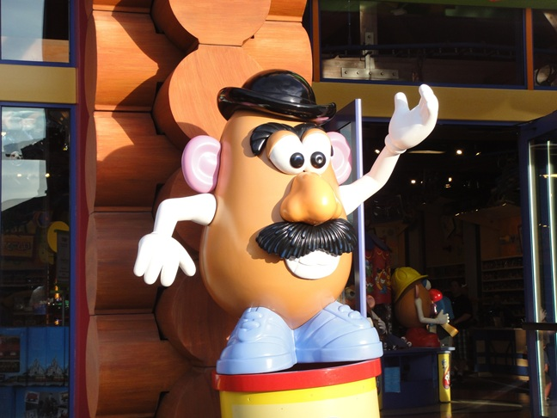

We are all united: Verses 12–16
All age idea:
Have a short competition (it could be a race, building a tower, eating a biscuit… anything that works for your church) between two volunteers. Split the room to cheer for one side each. Next have them work together to complete the challenge. Have the whole room cheer for both.
Sensory idea:
Playdough to create sculptures of the church family.
We are all needed: Verses 17–22
All age idea:
Have some primed volunteers representing different body parts (e.g. Holding a picture of an eye, a hand, etc.) Interview them about what they can manage on their own, separate from the body.
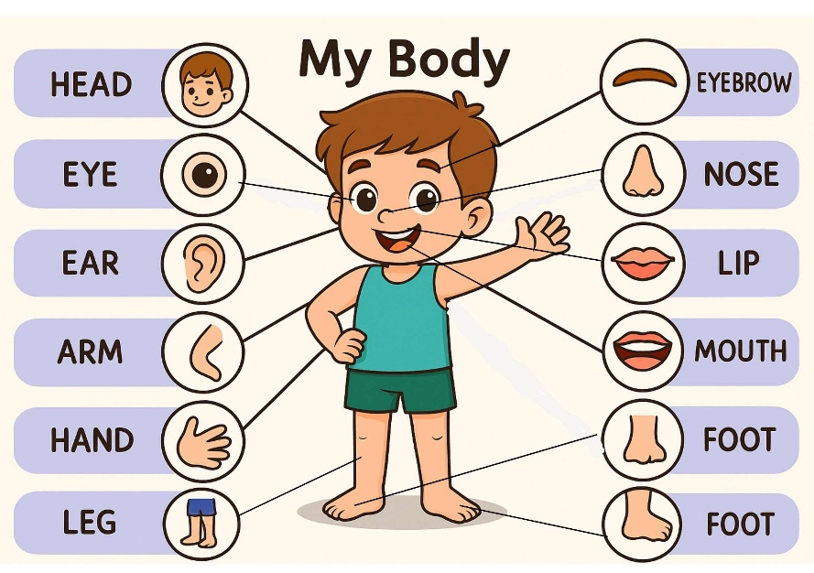
Sensory idea:
Guess what this is:
Have a variety of items that engage different senses, and each person has to guess what it is using only one body part: nose, eyes, ears, tongue. E.g. Tasting sugar and salt with eyes closed. Listening to an animal noise and guessing the animal. Feeling an object with eyes closed and guessing what it is. Smelling essential oils and guessing the scent.

We are all honoured: Verses 23–27
All age idea:
Under each chair is a Post-it note. Everyone writes a thank you to the person sat next to them for an act of kindness/service/contribution they have given at church. Suggest examples that work for everyone, so that everyone is able to give and receive a note, even if people don’t know one another well (e.g. Thank you for sitting next to me, thank you for smiling, thank you for being here today.)
Sensory idea:
Make crowns using tinfoil, pompoms and different textured materials.

Conclusion
We are the body and Christ is the Head. He is the one that brings this unity and gives us the freedom to be interdependent.
Copyright © Through the Roof.
Through the Roof Charitable Trust Ltd is a UK Registered Company number 04201510 with offices at Alpha House, Alpha Place, Garth Road, Morden SM4 4TQ.
It is also a Registered Charity Number 1087788.

