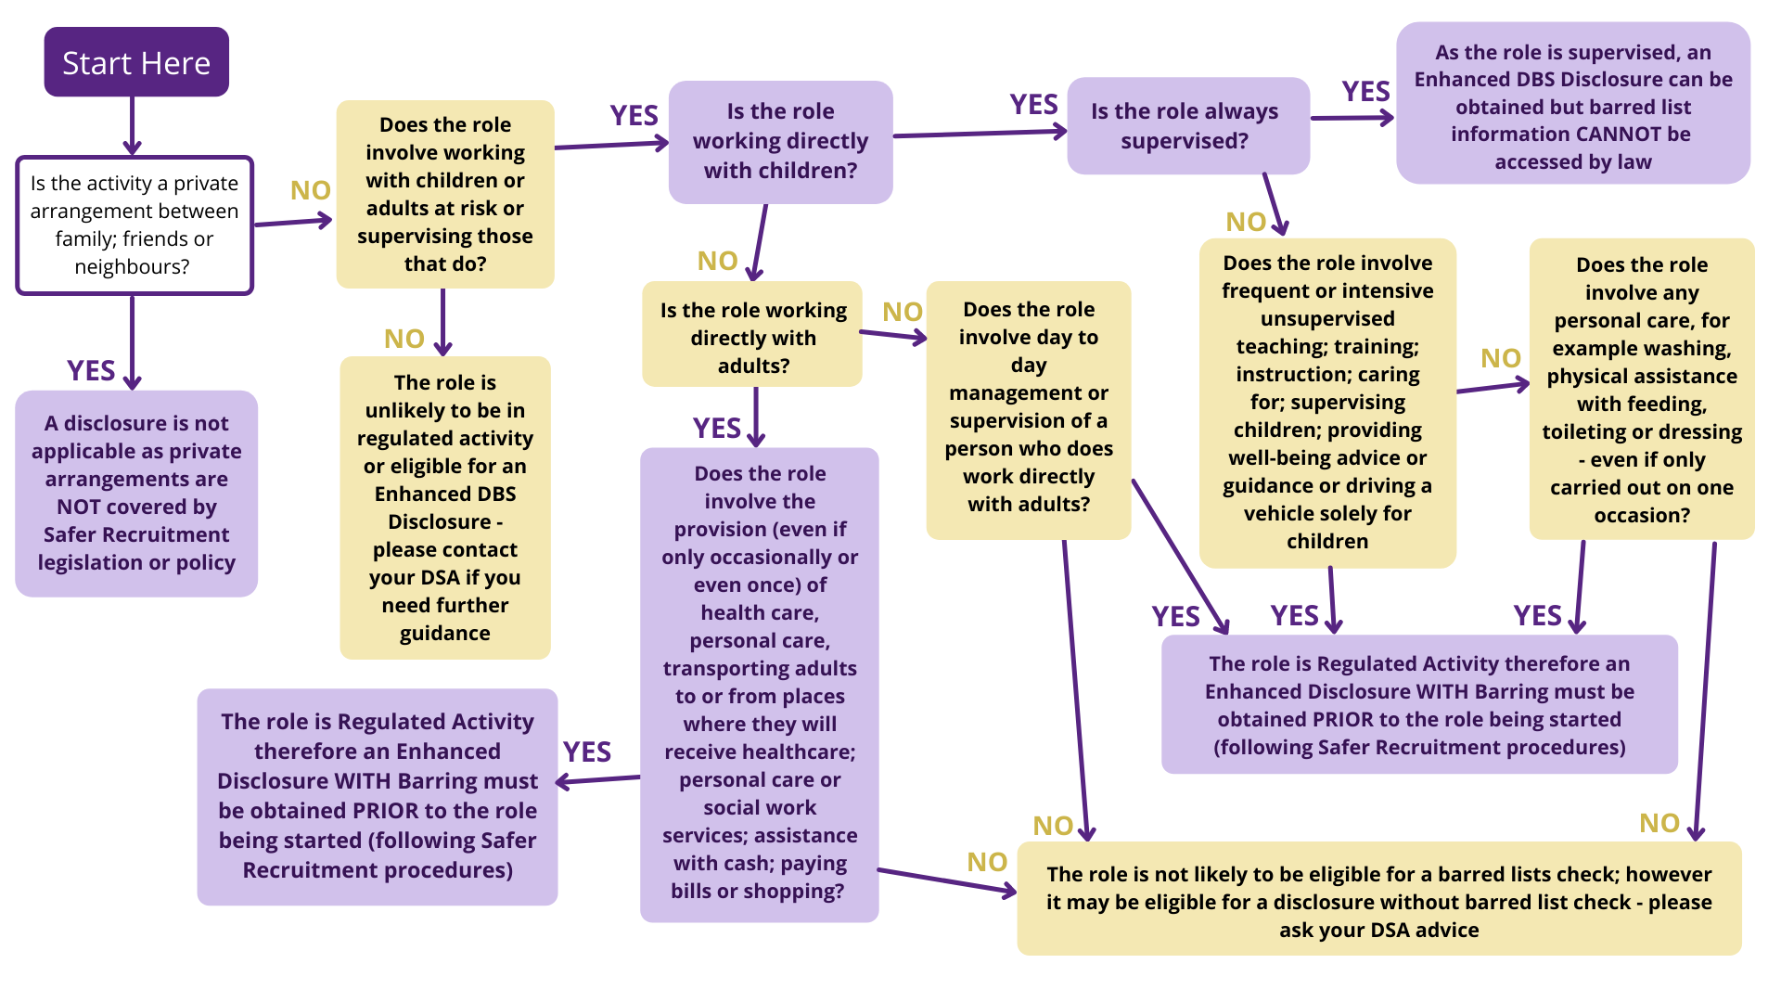
Regulated Activity Decision Making Flowchart

