This is the first page you see when you access your dashboard

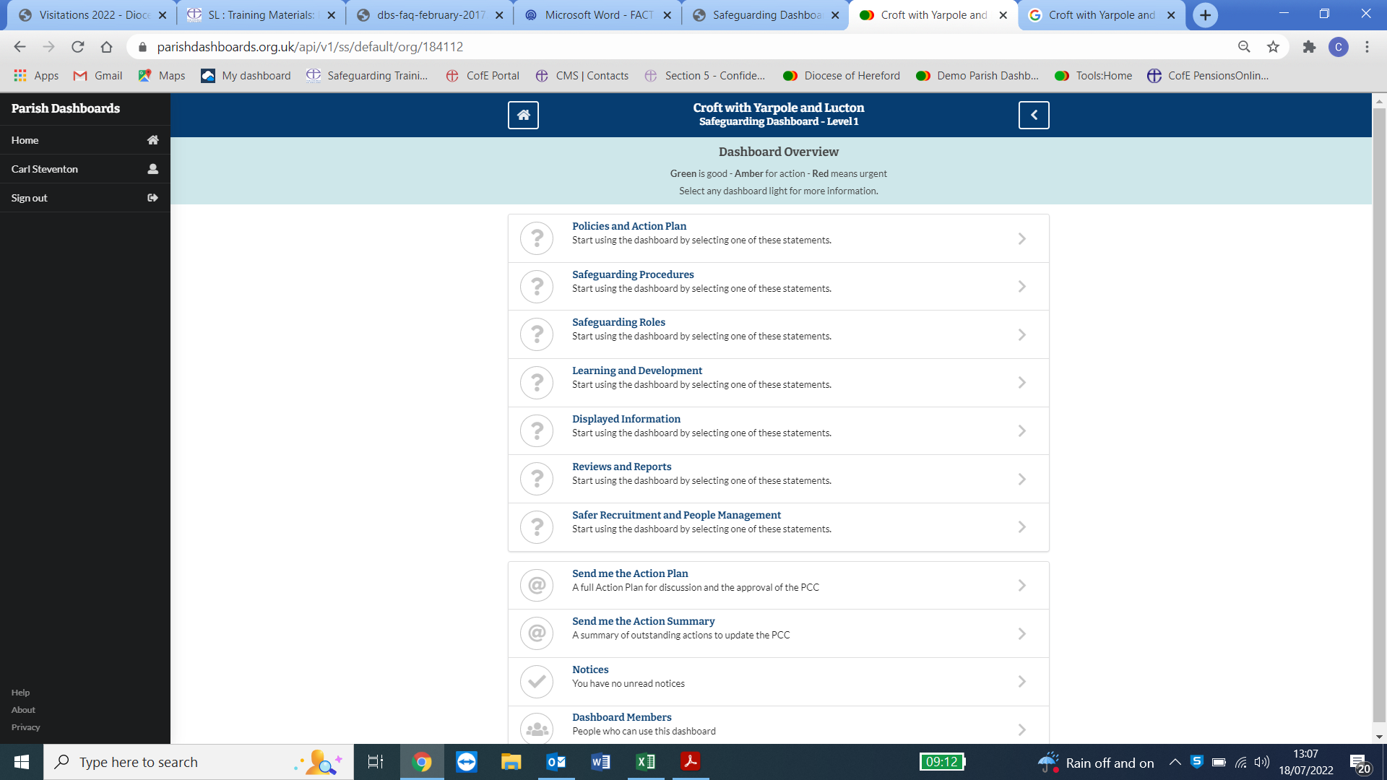

Here I have clicked on Policies and Action Plans and get the following screen

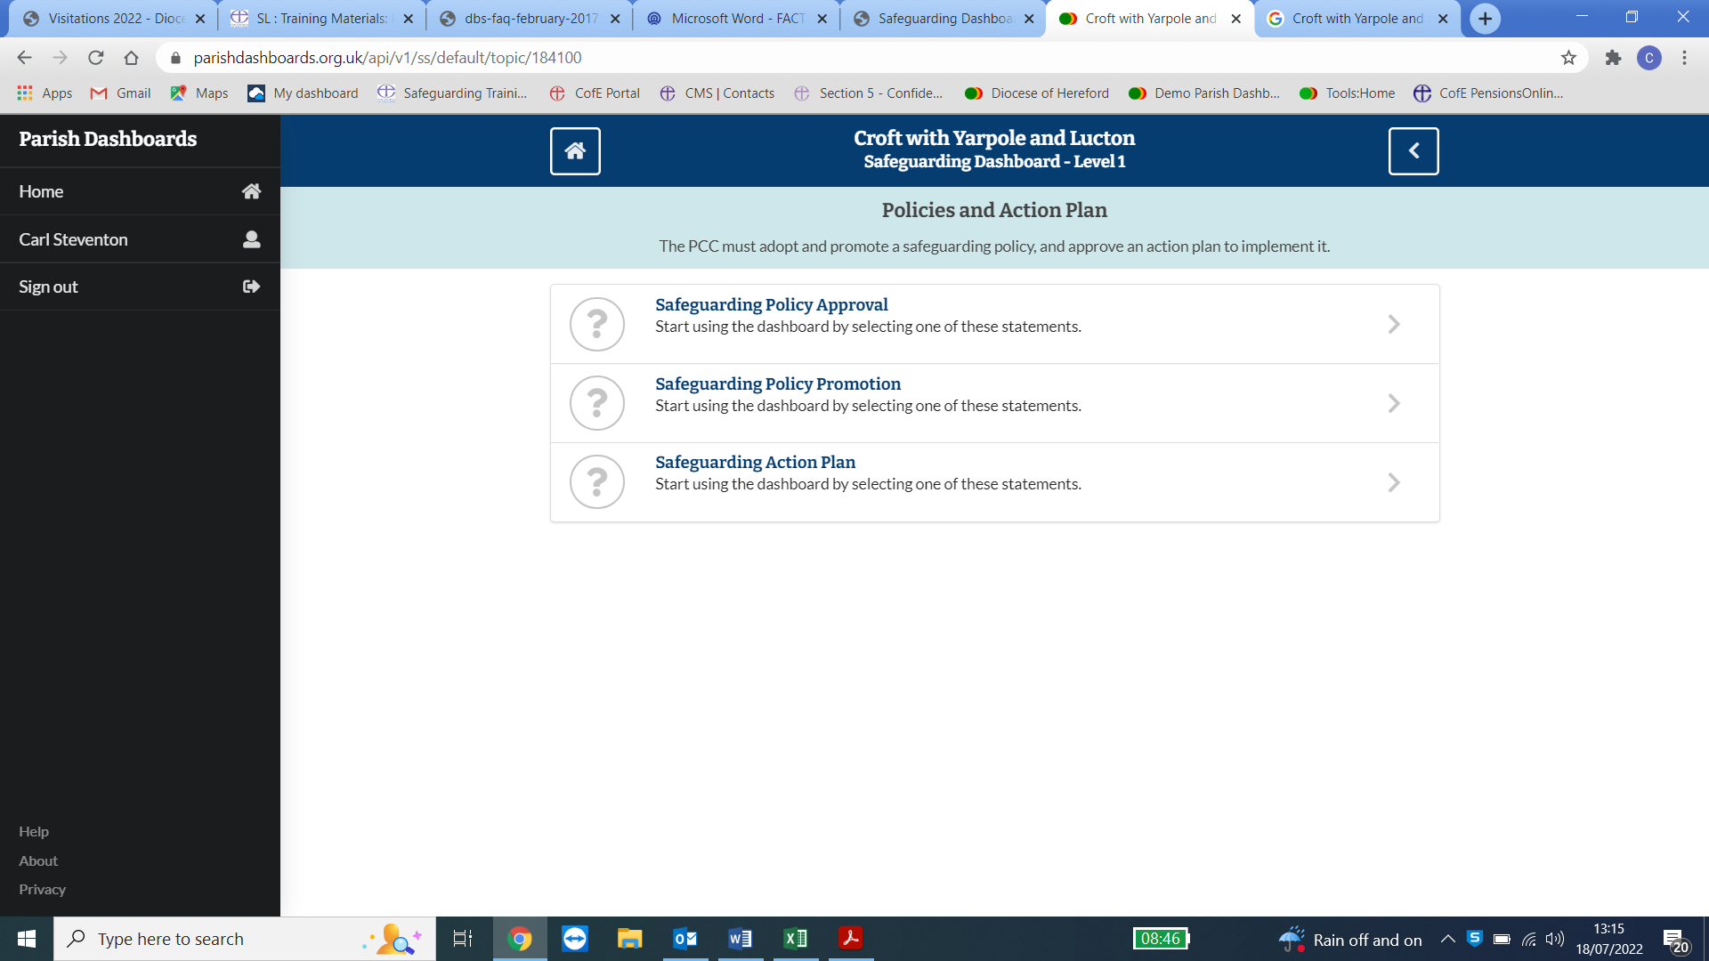

I have Clicked on Safeguarding Policy approval and opened the below screen.

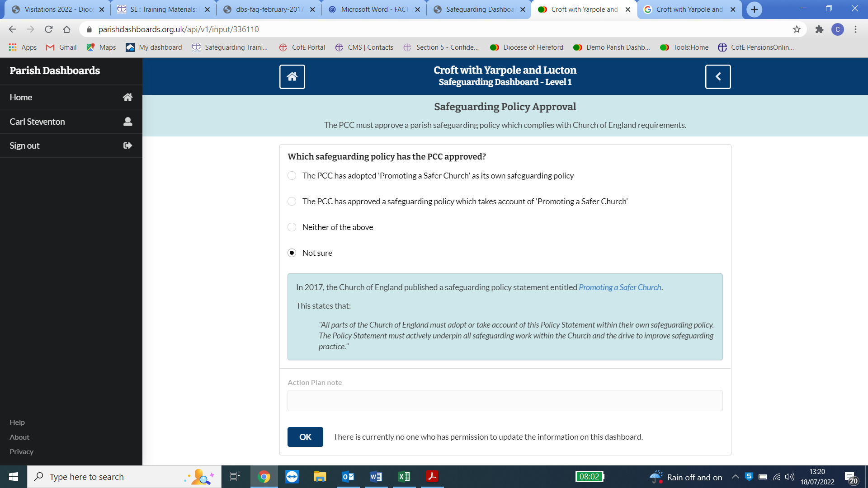

Always read the test in the blue boxes they will tell you everything about that question and contain links to relevant policy documents.

The one you would click on here is the **top one**. Click on it and click OK at the bottom.

It will then take you back one page and you will see that you have a green tick next to that statement. Like below.

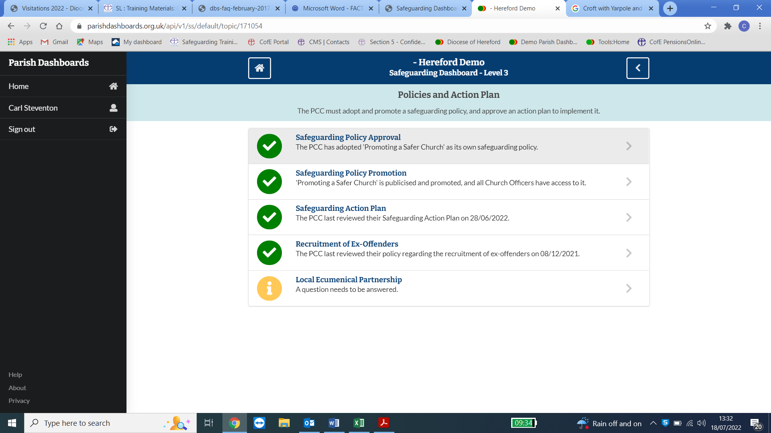

Have a look at the other 2 question mark links and see if you can answer them.

Go through the other parts of the dashboard and see if you can answer those questions. You may well be able to answer all the questions contained within ***“Displayed Information***”

Below I have clicked on the Safeguarding Action Plan Button and it opens up the below screen.

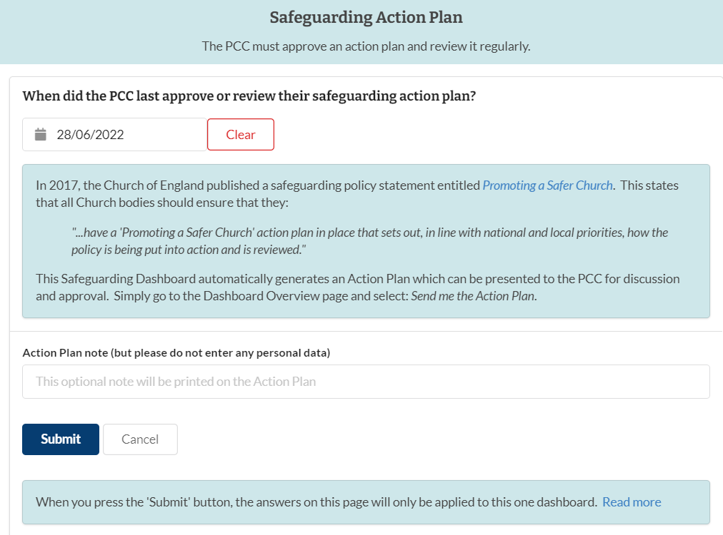

This asking you on what date did the PCC last approve or review their safeguarding action plan.

If you know the date click on the calendar icon (as shown with the arrow). This will open up the calendar box and scroll through to select the correct date. Once you have selected the date click on Submit and it will turn that box green with a tick.

The only time you would need to change that is when the Action Plan is reviewed again. You would just go in and change the date to the new one.

The ambition is to try and turn as many questions into green ticks as possible. Don’t panic if you can’t turn them all green, as some you may never will.