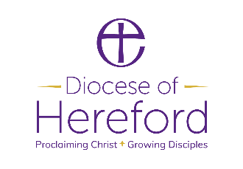
Diocesan Board of Education
PARTNERSHIP AGREEMENT FORM
Academic Year
2020-2021
1 September 2020 – 31 August 2021

School/Academy (single):
Name of Federation of Schools:
Multi Academy Trust:
(Please list schools in Federation or MAT below)

Name of School | NOR at Census  October 2019 | Amount per School  £500 for <100 NOR  £750 for 101-200 NOR  £1000 for >200 NOR
Discount Federation/MATS  (If applicable) | 25%
Total

25 % reduction for Federations or Academy Trust (see Page 8 of the Partnership Document for calculation details)

When schools or academies are working in Federations or Multi Academy Trusts, where possible we will seek to conduct any training and support across all schools.
Please be proactive in booking training/support hours and agreeing a focus that meets your school’s needs.
I confirm that I have read and understood the contents of this Partnership Agreement and agree that it accurately reflects my fair understanding of the services that provided.

Signed: Date:

Print Name:

Headteacher:

Please return by email to education@hereford.anglican.org
Invoices will be 30 days’ payment terms.

