Our mission context: the area, people, places we serve Now? Changes anticipated over the next five years?

Where we see signs of God at work locally
Where we see growth / encouragements and what we can build on /develop from these

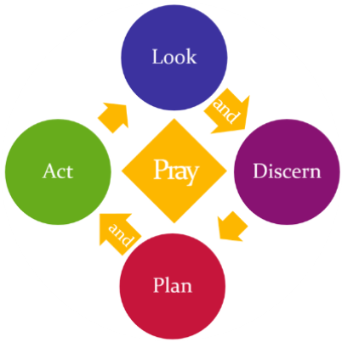
Our strengths, weaknesses, opportunities and threats as we see them as a parish/benefice:
Strengths | Weaknesses |  | Opportunities |  | Challenges
People and Resources: Now? Anticipated? Think about clergy and lay ministers, parish officers, new ministries, vocations, opportunities/needs for deployment etc

Our current vision for this parish/benefice in five years time

Looking back – Celebrating what we achieved in 2017 |  | Looking forward - Action we are planning for 2018/19 (2020?) |  | How we will tell how we’ve done  – what we are hoping to achieve through our action
MISSION Shared Priority 1: Growing Christians and church all ages and backgrounds (spiritual and numerical growth)

MISSION Shared Priority 2: Contributing to the Common Good – transforming lives and communities
MINISTRY “Reimagining” ministry - sharing ministry and equipping lay and ordained for ministry in 21st century
RESOURCES Part 1: Focusing our resources – money, buildings, time, people etc - where there is greatest mission need and opportunity
RESOURCES Part 2: Specific training and support requests

