1947Our mission context: the area, people, places we serve Now? Changes anticipated over the next five years?

Where we see signs of God at work locally Where we see growth / encouragements
What we can learn from each other /spread / build on /develop

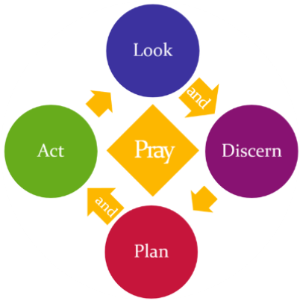
Our strengths, weaknesses, opportunities and threats as we see them as a deanery:
Strengths | Weaknesses |  | Opportunities |  | Threats
People and Resources: Now? Anticipated? Think about clergy and lay ministers, parish officers, new ministries, vocations, opportunities/needs for deployment etc

Our discernment of our way forward together as a deanery Our current vision for this deanery in 5 years time (Outline initial steps to achieve that overleaf)

Looking back - What we achieved in 2016 |  | Deanery action planned for 2017/18 (2019?) |  | Our goals and “measures of success”
Shared Priority 1: Growing disciples of all ages and backgrounds – spiritually and numerically
Shared Priority 2: Serving the common good – transforming lives and communities
Shared Priority 3: Sharing, developing and reimagining ministry for mission in the 21st century
Shared Commitment: to focusing our resources – money, buildings, time, people etc - where there is greatest mission need and opportunity

