NAME OF CHURCH

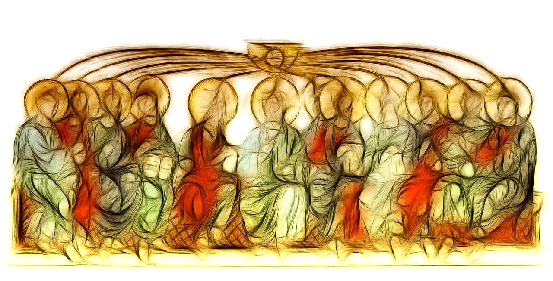

Pentecost Service
DATE

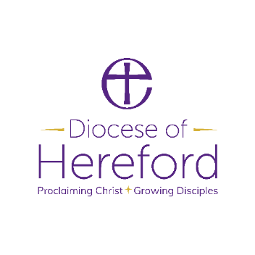

The Gathering
Welcome to NAME OF LOCATION, as we join together to worship God.
Suggestions have been made about when to sit or stand at different points during the service, if you are able. However, please do what helps you to enter into the worship of God.

Please stand.
Opening Hymn
ADD HYMN NUMBER OR LYRICS
(Suggestion: ‘Come down O Love divine’ or ‘Jesus is Lord’)

Welcome and Introduction
In the name of the Father,
and of the Son and of the Holy Spirit.
All Amen

The Lord be with you.
All And also with you.

Jesus Christ, whom we worship, is our crucified, risen and ascended Lord and we have walked with him through his journey of love.
We have faced the agony of his suffering and death on a cross.
We have rejoiced at his bursting free from the bonds of death.
We have enjoyed his risen presence with us
and his revelation of himself through the breaking of bread.
We have seen his return to the throne before which every knee shall bow and every tongue confess that this Jesus is Lord.
And now, with the followers of his own time,
we await the coming of the promised Holy Spirit, his gift to his people, through whom we make Christ known to the world.

The Responsary
As we wait in silence,
All make us ready for your coming Spirit.
As we listen to your word,
All make us ready for your coming Spirit.
As we worship you in majesty,
All make us ready for your coming Spirit.
As we long for your refreshing,
All make us ready for your coming Spirit.
As we long for your renewing,
All make us ready for your coming Spirit.
As we long for your equipping,
All make us ready for your coming Spirit.
As we long for your empowering,
All make us ready for your coming Spirit.

The Collect
Let us pray.
God, who as at this time taught the hearts of your faithful people
by sending to them the light of your Holy Spirit:
grant us by the same Spirit
to have a right judgement in all things
and evermore to rejoice in his holy comfort;
through the merits of Christ Jesus our Saviour,
who is alive and reigns with you,
in the unity of the Holy Spirit,
one God, now and for ever.
All Amen.

Hymn
ADD HYMN NUMBER OR LYRICS
(Suggestion: ‘Be still, for the presence of the Lord’ or ‘Holy Spirit, living breath of God’)

Pentecost
When the day of Pentecost had come, they were all together in one place. And suddenly from heaven there came a sound like the rush of a violent wind, and it filled the entire house where they were sitting. Divided tongues, as of fire, appeared among them, and a tongue rested on each of them. All of them were filled with the Holy Spirit and began to speak in other languages, as the Spirit gave them ability. Now there were devout Jews from every nation under heaven living in Jerusalem. And at this sound the crowd gathered and was bewildered, because each one heard them speaking in the native language of each. Amazed and astonished, they asked, ‘Are not all these who are speaking Galileans? And how is it that we hear, each of us, in our own native language? Parthians, Medes, Elamites, and residents of Mesopotamia, Judea and Cappadocia, Pontus and Asia, Phrygia and Pamphylia, Egypt and the parts of Libya belonging to Cyrene, and visitors from Rome, both Jews and proselytes, Cretans and Arabs – in our own languages we hear them speaking about God’s deeds of power.’ All were amazed and perplexed, saying to one another, ‘What does this mean?’ But others sneered and said, ‘They are filled with new wine.’ (Acts 2.1-13)

This is the Word of the Lord.
All Thanks be to God.

The Prayers of Intercession
We pray for God to fill us with his Spirit.
Generous God, we thank you for the power of your Holy Spirit.
We ask that we may be strengthened to serve you better.
Lord, come to bless us
All and fill us with your Spirit.
We thank you for the wisdom of your Holy Spirit.
We ask you to make us wise to understand your will.
Lord, come to bless us
All and fill us with your Spirit.
We thank you for the peace of your Holy Spirit.
We ask you to keep us confident of your love wherever you call us.
Lord, come to bless us
All and fill us with your Spirit.
We thank you for the healing of your Holy Spirit.
We ask you to bring reconciliation and wholeness
where there is division, sickness and sorrow.
Lord, come to bless us
All and fill us with your Spirit.
We thank you for the gifts of your Holy Spirit.
We ask you to equip us for the work which you have given us.
Lord, come to bless us
All and fill us with your Spirit.
We thank you for the fruit of your Holy Spirit.
We ask you to reveal in our lives the love of Jesus.
Lord, come to bless us
All and fill us with your Spirit.
We thank you for the breath of your Holy Spirit,
given us by the risen Lord. We ask you to keep the whole Church, living and departed, in the joy of eternal life.
Lord, come to bless us
All and fill us with your Spirit.

Generous God,
you sent your Holy Spirit upon your Messiah at the river Jordan,
and upon the disciples in the upper room:
in your mercy fill us with your Spirit,
All hear our prayer,
and make us one in heart and mind
to serve you with joy for ever. Amen.

The Lord’s Prayer
We invite you to join in the prayer
that Jesus’ taught his disciples: (either version can be used)
All Our Father who art in heaven, hallowed be thy name.
Thy kingdom come, Thy will be done,
on earth as it is in heaven.
Give us this day our daily bread.
And forgive us our trespasses
as we forgive those who trespass against us.
And lead us not into temptation,
but deliver us from evil.
For thine is the kingdom,
the power and the glory,
for ever and ever. Amen.

The Peace
God has made us one in Christ.
He has set his seal upon us and, as a pledge of what is to come,
has given the Spirit to dwell in our hearts. Alleluia.
(cf 2 Corinthians 1.22)
The peace of the Lord be always with you.
All And also with you.

We share the peace of Christ with those around us,

Hymn
ADD HYMN NUMBER OR LYRICS
(Suggestion: ‘Thou who camest from above’ or ‘The Spirit lives to set us free’)
The minister goes to the Easter Candle.
Blessed are you, sovereign God, overflowing in love.
With Pentecost dawns the age of the Spirit.
Now the flame of heaven rests on every believer.
Strong and weak, women and men tell out your word;
the young receive visions, the old receive dreams.
With the new wine of the Spirit
they proclaim your reign of love.
Amid the birth pangs of the new creation
the way of light is made known.
Source of freedom, giver of life,
blessed are you, Father, Son and Holy Spirit.
All Blessed be God for ever.

Each member of the congregation is given a candle which is lit, during which we sing (suggestions ‘There is a Redeemer’ or Send forth your Spirit, Lord)
Commission
When all the candles are lit the minister says
For fifty days we have celebrated the victory of our Lord Jesus Christ over the powers of sin and death. We have proclaimed God’s mighty acts and we have prayed that the power that was at work when God raised Jesus from the dead might be at work in us.
As part of God’s Church here in the Benefice of N, I call upon you to live out what you proclaim.

Empowered by the Holy Spirit,
will you dare to walk into God’s future,
trusting him to be your guide?
All By the Spirit’s power, we will.
Will you dare to embrace each other and grow together in love?
All By the Spirit’s power, we will.
Will you dare to share your riches in common
and minister to each other in need?
All By the Spirit’s power, we will.
Will you dare to pray for each other
until your hearts beat with the longings of God?
All By the Spirit’s power, we will.
Will you dare to carry the light of Christ into the world’s dark places?
All By the Spirit’s power, we will.
The Easter Candle is extinguished.
Final Hymn
ADD HYMN NUMBER OR LYRICS
(Suggestion: ‘Shine Jesus Shine or ‘The Spirit lives to set us free’)
The Dismissal
We stand together and listen to these words of blessing.
The Lord is here.
All His Spirit is with us.
Today we have remembered the coming of God’s power on the disciples and we invite that same Spirit to drive us out into the wild places of the world.
Filled with the Spirit’s power,
go in the light and peace of Christ. Alleluia, alleluia.
All Thanks be to God. Alleluia, alleluia.
Material from Common Worship (copyright © The Archbishops’ Council)
Hymns are covered by the Christian Copyright Licensing under CCL Licence No. XXXXX.

