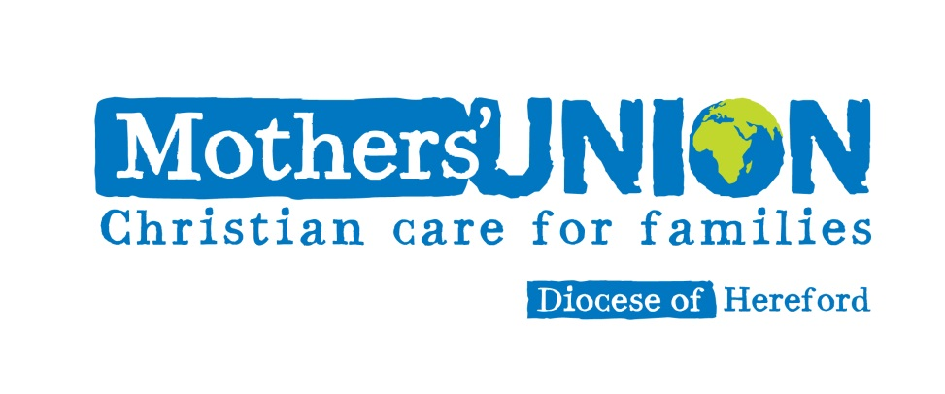

Resources for
Midday Prayers

at the Cathedral

It is the custom of members of the Mothers’ Union worldwide to pause for prayer at midday. The words in this leaflet may be used at this time, and you are invited to join in with them

The Mothers’ Union Prayer
Loving Lord
We thank you for your love so freely given to us all.
We pray for families around the world.
Bless the work of the Mothers’ Union
as we seek to share your love through
the encouragement, strengthening and support of marriage and family life.
Empowered by your Spirit,
may we be united in prayer and worship,
and in love and service
reach out as your hands across the world.
In Jesus’ name, Amen

The Lord’s Prayer
Our Father, who art in heaven,
hallowed be thy name
Thy kingdom come, thy will be done,
on earth as it is in heaven
Give us this day our daily bread
And forgive us our trespasses
as we forgive them who trespass against us
And lead us not into temptation,
but deliver us from evil
For thine is the kingdom,
the power and the glory,
for ever and ever, Amen
Mary Sumner’s Prayer
All this day, O Lord,
let me touch as many lives as possible for thee;
and every life I touch, do thou by thy Spirit quicken,
whether through the word I speak,
the prayer I breathe,
or the life I live, Amen

Words of dedication to service adapted from St Teresa of Avila
Christ has no body now on earth but ours,
no hands but ours,
no feet but ours.
Ours are the eyes through which we must look out
with Christ’s compassion on the world.
Ours are the feet with which Christ
is to go about doing good,
ours are the hands with which Christ blesses us now.

The Mothers’ Union exists to:
- uphold Christ’s teaching on the nature of marriage and promote its wider understanding
- encourage parents to bring up their children in the faith and life of the Church
- maintain a worldwide fellowship of Christians united in prayer, worship and service
- promote conditions in society favourable to stable family life and the protection of children
- help those whose family life has met with adversity

In Hereford Diocese, we are linked as partners in prayer to our sisters and brothers in the Mothers’ Union in:
Yambio in South Sudan
Garissa in Kenya
Mbamili in Nigeria
Willochra in Australia
and Thailand

Each week, we also pray for Mothers’ Union members in other dioceses throughout the worldwide Anglican Communion in a wave of prayer.

To find out more about the Mothers’ Union,
see our website: www.mothersunion.org

