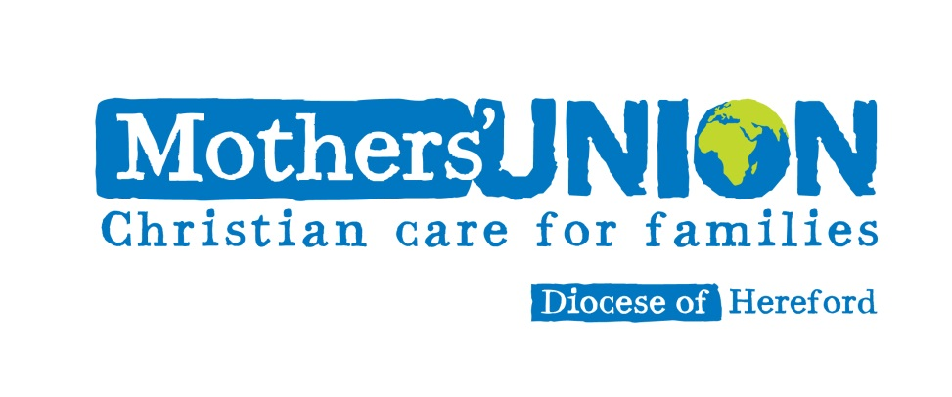
Membership Service

This service is for new members and existing members to affirm and reaffirm their commitment to the Mothers’ Union.
To be led by a Minister or Mothers’ Union office holder, ideally within Sunday worship but can equally well be used on its own.

Leader: Will the members of the Mothers’ Union please stand.

A member: The purpose of the Mothers’ Union is to be specially concerned with all that strengthens and preserves marriage and Christian family life.

The aim of the Society is the advancement of the Christian religion in the sphere of marriage and family life. In order to carry out its Aim, its Objects are:
- To uphold Christ’s teaching on the nature of marriage and promote its wider understanding
- To encourage parents to bring up their children in the faith and life of the Church
- To maintain a worldwide fellowship of Christians united in prayer, worship and service
- To promote conditions in society favourable to stable family life and the protection of children
- To help those whose family life has met with adversity

Leader: Membership of the worldwide Mothers’ Union is open to all who have been baptized in the name of the Holy Trinity and who declare support for the Aim and Objects of the Mothers’ Union. I ask both new and present members to join in affirming their commitment to the Mothers’ Union. Do you reaffirm your baptism promises?

All: I do, with God’s help.

Leader: Will you try to uphold and support the Aim and Objects of the Mothers’ Union?

All: I will, with God’s help.

Leader: Will you continue to plan your life to include prayer and Bible reading and worship in Church?

All: I will, by the grace of God.

Leader: (Name/s), I admit you to membership of the Mothers’ Union, in the name of the Father and of the Son and of the Holy Spirit.

The leader greets each new member and they are given their membership card and badge.

If members have moved from another branch / diocese, include the following:

Leader: We welcome (name/s) from (branch / diocese). Members of the Mothers’ Union, will you welcome, support and pray for each other?

All: We will, in the power of the Spirit.

Leader: We commit ourselves to the work of Jesus Christ through our membership, saying together the Mothers’ Union prayer:

All: Loving Lord
We thank you for your love so freely given to us all.
We pray for families around the world.
Bless the work of the Mothers’ Union
as we seek to share your love through
the encouragement, strengthening and support of marriage and family life.
Empowered by your Spirit,
may we be united in prayer and worship,
and in love and service
reach out as your hands across the world.
In Jesus’ name, Amen

Leader: Heavenly Father, as members of this branch we commit its life to you, we seek your blessing in all we do; your presence in our fellowship; your inspiration in our activities; your strength in our service to the Church and the community; help us to be faithful in prayer and worship and outgoing in our witness to the gospel, that we may advance your kingdom and glorify your name, through Jesus Christ our Lord, Amen.

