NAME OF CHURCH

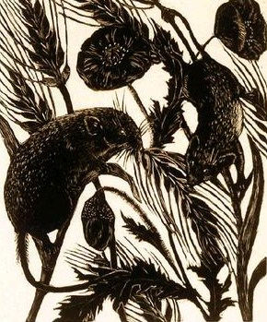

Harvest Service
DATE

The Gathering
Welcome to NAME OF LOCATION, as we join together to worship God.
Suggestions have been made about when to sit or stand at different points during the service, if you are able. However, please do what helps you to enter into the worship of God.

Please stand.
Opening Hymn
ADD HYMN NUMBER OR LYRICS
(Suggestion: Come ye thankful people come)

Welcome and Introduction
In the name of the Father,
and of the Son and of the Holy Spirit.
All Amen

The Lord be with you.
All And also with you.

Eternal God You crown the year with your goodness
and you give us the fruits of the earth in their season, Grant that we may use them wisely;
to your glory, for the relief of those in need
and for our own wellbeing
All Amen

Confession
(Please sit or kneel)
Our sin affects all those around us, therefore we confess our sins in penitence and faith.
Consider the birds of the air; They do not sow or gather into barns, yet our heavenly Father feeds them Lord have mercy
All Lord have mercy
Consider the lilies of the field, how they grow, They do not toil or spin, yet even Solomon in all his glory was not arrayed like one of these. Christ have mercy
All Christ have mercy
How little faith we have. Seek first the kingdom of God and his righteousness. Lord have mercy
All Lord have mercy
May the almighty and merciful Lord
grant us pardon and forgiveness of all our sins,
time for amendment of life,
and the grace and strength of the Holy Spirit.
All Amen

Reading: Psalm 67
May God be gracious to us and bless us
and make his face to shine upon us,
that your way may be known upon earth,
your saving power among all nations.
All Let the peoples praise you, O God;
let all the peoples praise you.
Let the nations be glad and sing for joy,
for you judge the peoples with equity
and guide the nations upon earth.
All Let the peoples praise you, O God;
let all the peoples praise you.
The earth has yielded its increase;
God, our God, has blessed us.
May God continue to bless us;
Let all the ends of the earth revere him.
All Glory be to the Father, and to the Son, and to the Holy Spirit,
as it was in the beginning, is now and shall be forever. Amen

Hymn
ADD HYMN NUMBER OR LYRICS
(Suggestion: We plough the fields and scatter)

Reading: Matthew 15.32-39

Talk

The Bringing Forward of Symbols of the Harvest
Let us bring forward symbols of the harvest,
gifts that God has created and his sun and rain have nurtured.
All Thanks be to God.
Bring forward the harvest of the cornfields,
the oats and the wheat, the rye and the barley.
All Thanks be to God.
Bring forward the harvest of vegetables,
peas, potatoes, beans and hops.
All Thanks be to God.
Bring forward the harvest of pears and apples, berries and herbs.
All Thanks be to God.
Bring forward the harvest of flowers,
the finest blooms from our gardens and our fields.
All Thanks be to God.
Bring forward the grain and the grape,
for our Saviour took bread and wine
to feed us with his body and his blood,
given and shed for the life of the world.
Let us feed on him by faith with thanksgiving.
All Thanks be to God.
Praise God, from whom all blessings flow,
praise him, all creatures here below,
praise him above, ye heavenly host,
praise Father, Son, and Holy Ghost.
Amen.

Hymn
ADD HYMN NUMBER OR LYRICS
(Suggestion: Harvest Samba)
The Peace
The harvest of the Spirit is love, joy, peace,
patience, kindness, goodness,
faithfulness, gentleness and self-control.
cf Galatians 5.22,23
The Lord be with you
All And also with you.
Let us offer one another a sign of peace.

The Prayers
God, the beginning and end of all things: We pray for farmers and agricultural workers , for packers , distributors and company boards; as we depend upon each other, enable us by your grace to seek the well being of others before our own. Lord of all creation;
All hear our prayer.
We pray for all those engaged in research to safeguard crops against disease, and to produce abundant life among those who hunger. Prosper the work of their hands and the searching of their minds, that their labour may be for the welfare of all. Lord of all wisdom:
All hear our prayer.
We pray for governments and aid agencies, and those areas of the world where there is disaster, drought and starvation. Help all of us to be wise stewards of your gifts, sharing from our abundance with those in need. Help us to support those who are worried about the future of their farms or livelihoods, or those who are depressed and in special need at this time Lord of all justice:
All hear our prayer.
The Lord’s Prayer
We invite you to join in the prayer
that Jesus’ taught his disciples: (either version can be used)
All Our Father who art in heaven,
hallowed be thy name.
Thy kingdom come,
Thy will be done,
on earth as it is in heaven.
Give us this day our daily bread.
And forgive us our trespasses
as we forgive those who trespass against us.
And lead us not into temptation,
but deliver us from evil.
For thine is the kingdom,
the power and the glory,
for ever and ever.
Amen.

Hymn
ADD HYMN NUMBER OR LYRICS
(Suggestion: Fill your hearts with joy and gladness)

The Blessing

Please stand for the peace.
May God our Creator ,
who clothes the lilies of the field
and feeds the birds of the air;
bestow upon us his care,
and help us to bear the fruits of his love, joy and peace;
and the blessing of God, Father, Son and Holy Spirit
be with us and remain with us always.
All Amen
Go in peace to love and serve the Lord.
All In the name of Christ. Amen

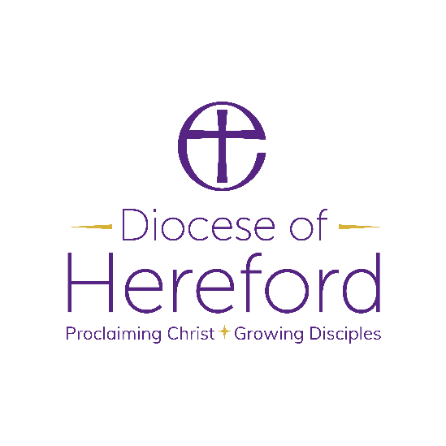

Material from Common Worship (copyright © The Archbishops’ Council)
Hymns are covered by the Christian Copyright Licensing under CCL Licence No. XXXXX.

