NAME OF CHURCH
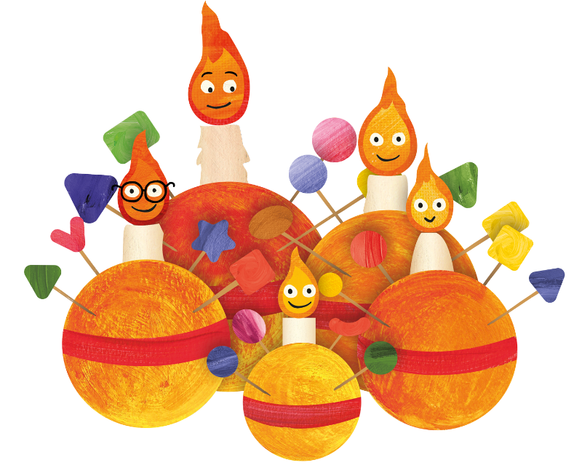

Christingle Service
DATE

The Gathering
Welcome to NAME OF LOCATION, as we join together to worship God.
Suggestions have been made about when to sit or stand at different points during the service, if you are able. However, please do what helps you to enter into the worship of God.

Please stand.
Opening Hymn
ADD HYMN NUMBER OR LYRICS
(Suggestion: Once in Royal David City, with the first verse sung by a child)

Welcome and Introduction
In the name of the Father,
and of the Son and of the Holy Spirit.
All Amen

The Lord be with you.
All And also with you.

Blessing of the Crib
God our Father,
on this night your Son Jesus Christ was born of the Virgin Mary for us and for our salvation:
bless this crib,
which we have prepared to celebrate that holy birth;
may all who see it be strengthened in faith
and receive the fullness of life he came to bring,
who is alive and reigns for ever.
All Amen

Luke 2.1-4: The journey begins….

Hymn
ADD HYMN NUMBER OR LYRICS
(Suggestion: Little Donkey)

Luke 2.5-7: Jesus is born

Hymn
ADD HYMN NUMBER OR LYRICS
(Suggestion: Away in a manger, with the children singing the first verse, and adults joining in from verse 2)

Luke 2.8-16: An angel appears to the shepherds

Hymn
ADD HYMN NUMBER OR LYRICS
(Suggestion: ‘See him lying on a bed of straw’ or ‘While shepherds watched their flocks’)
Matthew 2.9b-11: The Magi visit Jesus

Hymn
ADD HYMN NUMBER OR LYRICS
(Suggestion: ‘We Three Kings’)

The Prayers
Lord Jesus,
bringer of light to this world,
we pray that your light would shine in us
and that as a community we may reflect your light.
Lord in your mercy,
All hear our prayer.
Lord Jesus,
bringer of light to children and young people,
we pray for young people who are in dark situations.
Shine your light on those who feel hopeless and afraid
that they may have a brighter future.
Lord in your mercy,
All hear our prayer.
Lord Jesus,
bringer of light to the helpers,
we pray that you would be with those
who support young people.
Shine your light on teachers and carers in our community:
may they know your blessing upon them.
We pray for the work of The Children’s Society,
and all those who support their work
with vulnerable young people.
Lord in your mercy,
All hear our prayer.

The Lord’s Prayer
We invite you to join in the prayer
that Jesus’ taught his disciples: (either version can be used)
All Our Father who art in heaven,
hallowed be thy name.
Thy kingdom come,
Thy will be done,
on earth as it is in heaven.
Give us this day our daily bread.
And forgive us our trespasses
as we forgive those who trespass against us.
And lead us not into temptation,
but deliver us from evil.
For thine is the kingdom,
the power and the glory,
for ever and ever.
Amen.

Talk
During the talk the symbols of the Christingle are explained.

The Christingles
The Christingles are handed out, and the candles are lit. The lights are dimmed.

Hymn
ADD HYMN NUMBER OR LYRICS
(Suggestion: ‘Silent Night’ followed by ‘Hark the Herald Angels Sing’)

The Blessing

Please stand for the peace.
May the joy of the angels,
the eagerness of the shepherds,
the perseverance of the wise men,
the obedience of Joseph and Mary,
and the peace of the Christ-child
be yours this Christmas;
and the blessing of God almighty
be with us, this night and for evermore.
All Amen

A retiring collection is taken for the work of The Children’s Society

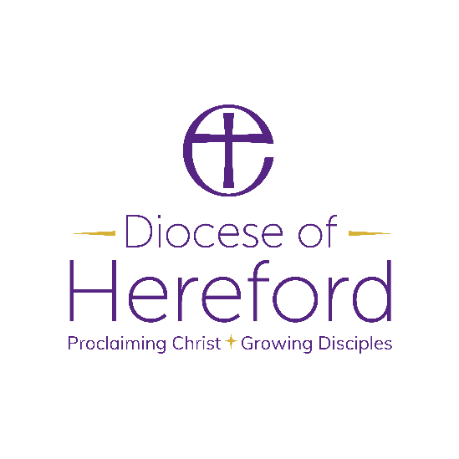

Material from Common Worship (copyright © The Archbishops’ Council)
Hymns are covered by the Christian Copyright Licensing under CCL Licence No. XXXXX.

