NAME OF CHURCH

Ash Wednesday Service
DATE

The Gathering
Welcome to NAME OF LOCATION, as we join together to worship God.
Suggestions have been made about when to sit or stand at different points during the service, if you are able. However, please do what helps you to enter into the worship of God.

Please stand.
Opening Hymn
ADD HYMN NUMBER OR LYRICS
(Suggestion: Forty days and forty nights)

Welcome and Introduction
In the name of the Father,
and of the Son and of the Holy Spirit.
All Amen

The Lord be with you.
All And also with you.

Let us pray for God’s grace to keep Lent faithfully.
Holy God,
our lives are laid open before you:
rescue us from the chaos of sin
and through the death of your Son
bring us healing and make us whole
in Jesus Christ our Lord.
All Amen

Reading: Psalm 51
Have mercy on me, O God, in your great goodness;
according to the abundance of your compassion
blot out my offences.
All Wash me thoroughly from my wickedness
and cleanse me from my sin.
For I acknowledge my faults and my sin is ever before me.
All Against you only have I sinned
and done what is evil in your sight,
So that you are justified in your sentence
and righteous in your judgement.
All I have been wicked even from my birth,
a sinner when my mother conceived me.
Behold, you desire truth deep within me
and shall make me understand wisdom
in the depths of my heart.
All Purge me with hyssop and I shall be clean;
wash me and I shall be whiter than snow.
Make me hear of joy and gladness,
that the bones you have broken may rejoice.
All Turn your face from my sins and blot out all my misdeeds.
Make me a clean heart, O God, and renew a right spirit within me.
All Cast me not away from your presence
and take not your holy spirit from me.
Give me again the joy of your salvation
and sustain me with your gracious spirit;
All Then shall I teach your ways to the wicked
and sinners shall return to you.
Deliver me from my guilt, O God, the God of my salvation,
and my tongue shall sing of your righteousness.
All O Lord, open my lips
and my mouth shall proclaim your praise.
For you desire no sacrifice, else I would give it;
you take no delight in burnt offerings.
All The sacrifice of God is a broken spirit;
a broken and contrite heart, O God, you will not despise.
O be favourable and gracious to Zion;
build up the walls of Jerusalem.
All Then you will accept sacrifices offered in righteousness,
the burnt offerings and oblations;
then shall they offer up bulls on your altar.

Take away, good Lord, the sin that corrupts us;
give us the sorrow that heals and the joy that praises
and restore by grace your own image within us,
that we may take our place among your people;
in Jesus Christ our Lord. Amen
The Promise of God’s Forgiveness
The Word of God is full of the promise, the accomplishment,
the proclamation and the explanation of God’s forgiveness.
So hear now these passages that speak of our loving Lord’s mercy.
From his word in the Old Testament…

To the Lord our God belong mercy and forgiveness,
for we have rebelled against him. Daniel 9.9

Who is a God like you, pardoning iniquity
and passing over the transgression
of the remnant of your possession?
He does not retain his anger for ever,
because he delights in showing clemency.
He will again have compassion upon us;
he will tread our iniquities under foot.
You will cast all our sins
into the depths of the sea. Micah 7.18-19
As far as the east is from the west,
so far has he set our sins from us. Psalm 103.12

From his word in the Gospels…

Jesus said: For if you forgive others their trespasses, your heavenly Father will also forgive you; but if you do not forgive others, neither will your Father forgive your trespasses. Matthew 6.14-15

Jesus took a cup, and after giving thanks he gave it to them, saying, ‘Drink from it, all of you; for this is my blood of the covenant, which is poured out for many for the forgiveness of sins. Matthew 26.27-28

From his word in the New Testament…

Be kind to one another, tender-hearted, forgiving one another,
as God in Christ has forgiven you. Ephesians 4.32

For I will be merciful towards their iniquities,
and I will remember their sins no more. Hebrews 8.12

If we confess our sins, he who is faithful and just will forgive us our sins and cleanse us from all unrighteousness. 1 John 1.9

For the word of the Lord:
All Thanks be to God.

Hymn
ADD HYMN NUMBER OR LYRICS
(Suggestion: O God you search me and you know me)
Confession
(Please sit or kneel)
Let us now call to mind our sin and the infinite mercy of God.
God the Father,
All have mercy on us.
God the Son,
All have mercy on us.
God the Holy Spirit,
All have mercy on us.
Trinity of love,
All have mercy on us.
Most merciful God,
All Father of our Lord Jesus Christ,
we confess that we have sinned
in thought, word and deed.
We have not loved you with our whole heart,
and mind, and strength.
We have not loved our neighbours as ourselves.
We have not forgiven others, as we have been forgiven.
All Lord, have mercy.
We have been deaf to your call to serve, as Christ served us.
We have not been true to the mind of Christ.
We have grieved your Holy Spirit.
All Lord, have mercy.
We confess to you, Lord, all our past unfaithfulness:
the pride, hypocrisy and impatience of our lives.
All Lord, have mercy.
Our self-indulgent appetites and ways,
and our exploitation of other people.
All Lord, have mercy.
Our anger at our own frustration
and our envy of those more fortunate than ourselves.
All Lord, have mercy.
Our intemperate love of worldly goods and comforts
and our dishonesty in daily life and work.
All Lord, have mercy.
Our negligence in prayer and worship
and our failure to commend the faith that is in us.
All Lord, have mercy.
Accept our repentance, Lord, for the wrongs we have done,
for our blindness to human need and suffering,
and our indifference to injustice and cruelty.
All Accept our repentance, Lord.
For all false judgements,
for uncharitable thoughts towards our neighbours
and for our prejudice and contempt towards those who differ from us.
All Accept our repentance, Lord.
For our waste and pollution of your creation
and our lack of concern for those who come after us.
All Accept our repentance, Lord.
Restore us, good Lord, and let your anger depart from us.
All Favourably hear us, for your mercy is great.
Accomplish in us the work of your salvation,
All that we may show your glory in the world.
By the cross and passion of your Son our Lord,
All bring us with all your saints to the joy of his resurrection.
Silence is kept.

All We have not loved you with our whole heart.
We have not loved our neighbours as ourselves.
In your mercy
forgive what we have been,
help us to amend what we are,
and direct what we shall be;
that we may do justly,
love mercy,
and walk humbly with you, our God. Amen.

Hymn
ADD HYMN NUMBER OR LYRICS
(Suggestion: Lord Jesus, think on me)

The Imposition of Ashes
Dear friends in Christ,
I invite you to receive these ashes
as a sign of the spirit of penitence
with which we shall keep this season of Lent.
God our Father,
you create us from the dust of the earth:
grant that these ashes may be for us
a sign of our penitence and a symbol of our mortality;
for it is by your grace alone that we receive eternal life
in Jesus Christ our Saviour.
All Amen.
Remember that you are dust, and to dust you shall return.
Turn away from sin and be faithful to Christ.

Prayer after the Imposition of Ashes
All God our Father,
the strength of all who put their trust in you,
mercifully accept our prayers;
and because, in our weakness,
we can do nothing good without you,
grant us the help of your grace,
that in keeping your commandments
we may please you, both in will and deed;
through Jesus Christ our Lord.
Amen.
The Lord’s Prayer
We invite you to join in the prayer
that Jesus’ taught his disciples: (either version can be used)
All Our Father who art in heaven,
hallowed be thy name.
Thy kingdom come,
Thy will be done,
on earth as it is in heaven.
Give us this day our daily bread.
And forgive us our trespasses
as we forgive those who trespass against us.
And lead us not into temptation,
but deliver us from evil.
For thine is the kingdom,
the power and the glory,
for ever and ever.
Amen.

Hymn
ADD HYMN NUMBER OR LYRICS
(Suggestion: There’s a wideness in God’s mercy)

The Dismissal

The Lord be with you
All and also with you.

May God give us grace to grow in holiness,
deny ourselves and take up our cross, and follow him.
All Amen
Go in peace to love and serve the Lord.
All In the name of Christ. Amen

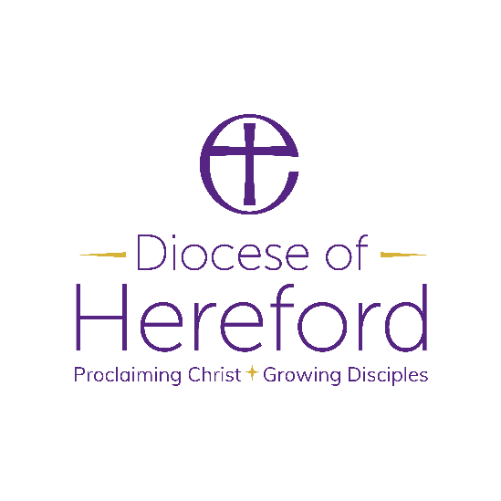

Material from Common Worship (copyright © The Archbishops’ Council)
Hymns are covered by the Christian Copyright Licensing under CCL Licence No. XXXXX.

