NAME OF CHURCH

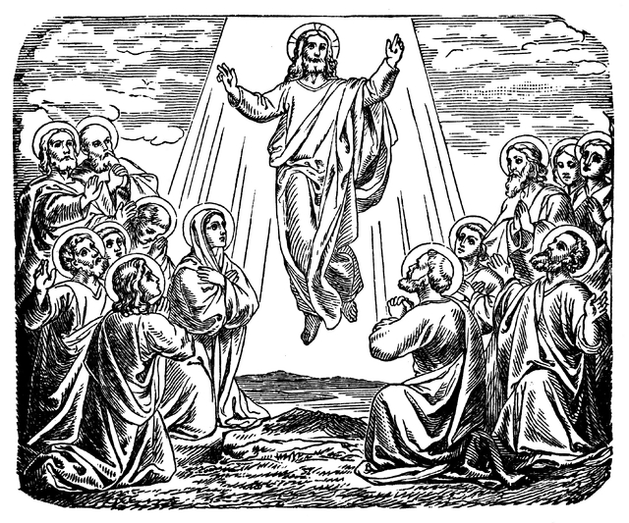

Ascension Day Service
DATE
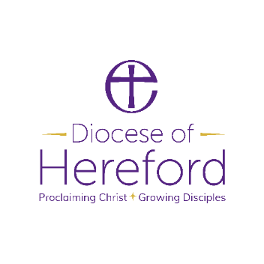
The Gathering
Welcome to NAME OF LOCATION, as we join together to worship God.
Suggestions have been made about when to sit or stand at different points during the service, if you are able. However, please do what helps you to enter into the worship of God.

Please stand.
Opening Hymn
ADD HYMN NUMBER OR LYRICS
(Suggestion: ‘Hail the Day that sees him rise’ or ‘Alleluia, sing to Jesus’)

Welcome and Introduction
In the name of the Father,
and of the Son and of the Holy Spirit.
All Amen

The Lord be with you.
All And also with you.

Dear brothers and sisters in Christ, for forty days we have been celebrating with joyful hearts the resurrection of our Lord Jesus Christ, his bursting from the tomb and his defeat of the power of sin and death. He appeared to his disciples many times and told them about the kingdom of God.

Today we recall how he left this earth and returned to his Father, ascending into heaven to take his throne over all dominions and powers. Trusting in his reign over all creation, and submitting to his kingly yet loving rule, let us hear the story of his parting.

The Resurrection Stations
Peter Finds the Empty Tomb
Then Peter and the other disciple set out and went towards the tomb. The two were running together, but the other disciple outran Peter and reached the tomb first. He bent down to look in and saw the linen wrappings lying there, but he did not go in. Then Simon Peter came, following him, and went into the tomb. He saw the linen wrappings lying there, and the cloth that had been on Jesus’ head, not lying with the linen wrappings but rolled up in a place by itself. Then the other disciple, who reached the tomb first, also went in, and he saw and believed. (John 20.3-8)

We praise you and we bless you,
our risen Lord Jesus, King of glory,
for in you our God reveals the awesome power of love
that is stronger even than death.
As in your dying you destroyed death,
so in your rising may we be raised above
the trials and torments of this world’s woe.
All To you, Lord Jesus,
the fullness of your life revealed in an empty tomb,
be honour and glory, now and for ever. Amen.

The Road to Emmaus
As they came near the village to which they were going, he walked ahead as if he were going on. But they urged him strongly, saying, ‘Stay with us, because it is almost evening and the day is now nearly over.’ So he went in to stay with them. When he was at the table with them, he took bread, blessed and broke it, and gave it to them. Then their eyes were opened, and they recognized him; and he vanished from their sight. They said to each other, ‘Were not our hearts burning within us while he was talking to us on the road, while he was opening the scriptures to us?’ That same hour they got up and returned to Jerusalem; and they found the eleven and their companions gathered together. They were saying, ‘The Lord has risen indeed, and he has appeared to Simon!’ Then they told what had happened on the road, and how he had been made known to them in the breaking of the bread. (Luke 24.28-35)

We praise you and we bless you,
our risen Lord Jesus, King of glory, for you are with us,
even when our eyes are closed to your companionship.
Walk this day alongside the disconsolate and the despairing,
open their eyes to your gentle illumination,
and let their hearts burn within them at your invisible presence.
All To you, Lord Jesus,
walking by our side,
be honour and glory, now and for ever.

Hymn
ADD HYMN NUMBER OR LYRICS
(Suggestion: ‘We have a gospel to proclaim’ or ‘Christ triumphant’) )

Jesus appears at the lakeside
When they had gone ashore, they saw a charcoal fire there, with fish on it, and bread. Jesus said to them, ‘Bring some of the fish that you have just caught.’ So Simon Peter went aboard and hauled the net ashore, full of large fish, a hundred and fifty-three of them; and though there were so many, the net was not torn. Jesus said to them, ‘Come and have breakfast.’ Now none of the disciples dared to ask him, ‘Who are you?’ because they knew it was the Lord. Jesus came and took the bread and gave it to them, and did the same with the fish. (John 21.9-13)

We praise you and we bless you,
our risen Lord Jesus, King of glory,
for at the lakeside you showed concern
for the daily needs of your disciples.
As you guided them to fill their nets with fish,
so guide all who are hungry
till their hunger is satisfied in you.
All To you, Lord Jesus,
sharing with us the food of faith,
be honour and glory, now and for ever.

The Responsary
As we wait in silence,
All make us ready for your coming Spirit.
As we listen to your word,
All make us ready for your coming Spirit.
As we worship you in majesty,
All make us ready for your coming Spirit.
As we long for your refreshing,
All make us ready for your coming Spirit.
As we long for your renewing,
All make us ready for your coming Spirit.
As we long for your equipping,
All make us ready for your coming Spirit.
As we long for your empowering,
All make us ready for your coming Spirit.

Hymn
ADD HYMN NUMBER OR LYRICS
(Suggestion: ‘I danced in the morning’)

The Ascension
While staying with the disciples, he ordered them not to leave Jerusalem, but to wait there for the promise of the Father. ‘This’, he said, ‘is what you have heard from me; for John baptized with water, but you will be baptized with the Holy Spirit not many days from now.’ So when they had come together, they asked him, ‘Lord, is this the time when you will restore the kingdom to Israel?’ He replied, ‘It is not for you to know the times or periods that the Father has set by his own authority. But you will receive power when the Holy Spirit has come upon you; and you will be my witnesses in Jerusalem, in all Judea and Samaria, and to the ends of the earth.’ When he had said this, as they were watching, he was lifted up, and a cloud took him out of their sight. While he was going and they were gazing up towards heaven, suddenly two men in white robes stood by them. They said, ‘Men of Galilee, why do you stand looking up towards heaven? This Jesus, who has been taken up from you into heaven, will come in the same way as you saw him go into heaven.’ (Acts 1.4-11)

We praise you and we bless you,
our risen Lord Jesus, King of glory,
for in your ascension you are crowned
King of kings and Lord of lords.
As we worship you on your heavenly throne,
prepare our hearts for the coming of your Spirit.
All To you, Lord Jesus, who will come back
in the same way you went up into heaven,
be honour and glory, now and for ever.

The Lord’s Prayer
We invite you to join in the prayer
that Jesus’ taught his disciples: (either version can be used)
All Our Father who art in heaven, hallowed be thy name.
Thy kingdom come, Thy will be done,
on earth as it is in heaven.
Give us this day our daily bread.
And forgive us our trespasses
as we forgive those who trespass against us.
And lead us not into temptation,
but deliver us from evil.
For thine is the kingdom,
the power and the glory,
for ever and ever. Amen.

The Dismissal
Jesus says: ‘Peace I leave with you; my peace I give to you.
If you love me, rejoice because I am going to the Father’. Alleluia. (John 14.27-28)

The peace of the Lord be always with you.
All And also with you.
We share the peace of Christ with those around us

Waiting expectantly for the promised Holy Spirit,
go in the peace of Christ. Alleluia, alleluia.
All Thanks be to God. Alleluia, alleluia.

Material from Common Worship (copyright © The Archbishops’ Council)
Hymns are covered by the Christian Copyright Licensing under CCL Licence No. XXXXX.

