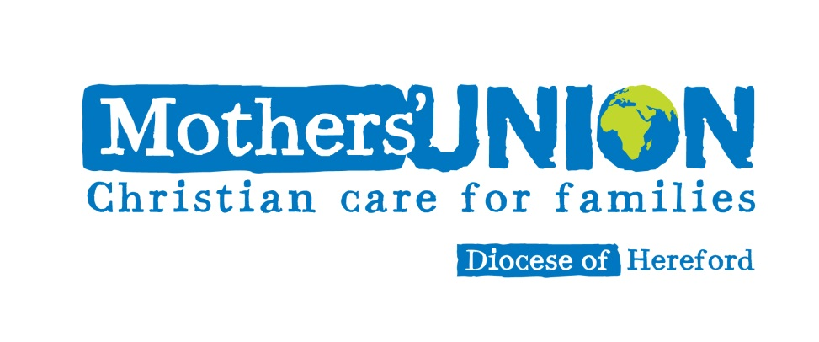
On Your Patch

Mothers’ Union exists to:
- uphold Christ’s teaching on the nature of marriage & promote its wider understanding
- encourage parents to bring up their children in the faith and life of the church
- maintain a worldwide fellowship of Christians united in prayer, worship and service
- promote conditions in society favourable to stable family life and the protection of children
- help those whose family life has met with adversity

but what is needed on your patch?

We are prayerful, and practical – but also pragmatic. We are few in number, and the simple reality is we can’t undertake big projects on our own. We don’t have the resources for that BUT we can help, and work in partnership with others who are working in their local communities on initiatives that accord with our aims.

So, what is on your patch, that you could help support? Here are a few ideas:

volunteering at parent and toddler groups

volunteering at the local Contact Centre, so children can see their parents in the midst of family breakdowns

hearing children read in schools

helping lead assemblies in schools

helping distribute meals for Meals on Wheels

assisting with community transport schemes, and sharing transport – offering lifts

raising awareness of existing support, and advice networks – CAB, WISH, parish councils, church groups, and other community groups

volunteering for community libraries and museums

keeping in touch with elderly parishioners and church members

visiting people in residential care homes, hospitals and hospices

befriending young families, especially new parents who may be feeling isolated

offering to babysit

acting as “Rent-a-Gran” for anyone who would value an older friend and mentor

working with “knit and knatter” and craft groups to make activity quilts and twiddle muffs

collecting household goods for our Crisis Intervention store

befriending refugees and migrant workers, for example, inviting them to church social events

supporting our food banks with supplies and volunteers

supporting initiatives in churches and communities – such as Messy Church, Open the Book, the Pub is the Hub, Home Start, engaging with marriage preparation, and baptism preparation, supporting the bereaved and grieving

supporting Fair Trade stalls and events

signing petitions and joining campaigning groups that support those in need

and above all PRAY for your neighbours!

