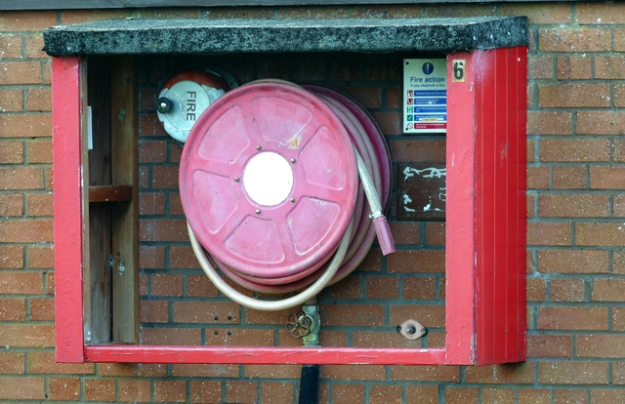
Fire Safety for Churches
Fortunately fires in occupied churches are relatively rare. Nonetheless all PCCs are required by law to carry out a Fire Risk Assessment; detailed advice about this is available from your church's insurer.
PCCs should identify the hazards and risks within a church building and take steps to remove, reduce and protect against them.
Most fires in churches arise from electrical faults; it is therefore essential that electrical installation tests are carried out once every five years
We should be mindful that when our churches are at their busiest - for example at a carol service or wedding then it likely many people present may not necessarily know where their nearest exit is - or what fire precautions are in place.
Risk assessments by PCCs must anticipate such events and plan accordingly. Steps could include nominating trained stewards for large events, who know where the fire extinguishers are kept and have been trained how to use them. Any fire extinguishers should be checked every year to ensure they are fit for purpose.
Fire safety for churches is covered by the Regulatory Reform (Fire Safety) Order 2005.
You can find out more on the following websites:
Hereford and Worcester Fire and Rescue Service website.
Church of England website
A major church insurer Ecclesiastical also has specific advice on its website.

